Week | News Story | Focus question | UN Article | British Value Link
29th  August | In San Francisco, USA, a hawk has been hired to deter pigeons from entering one of the metro transport system stations. | What is it like inside a train station? | 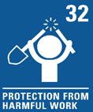 | Individual Liberty - Some people choose to train and teach animals to do jobs. It is important to remember that if we train an animal to do a job, we must make sure the animal is cared for, safe and happy.
5th  September | Strictly Come Dancing star, Rose Ayling Ellis, has teamed up with Barbie to unveil their first doll with behind the ear hearing aids. | Does it matter what dolls look like? | 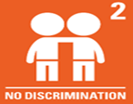 | Mutual Respect and Tolerance - Every single person in our world is different. We can learn about and celebrate our differences, which can help us to respect and value one another.
12th September | The UK is seeing many different workers taking the decision to strike (action taken against employers by refusing to work for a period of time), with rail workers, barristers, call centre staff and postal workers all exercising their right to strike over low pay or poor working conditions. | What can we do if we feel something isn’t fair? | 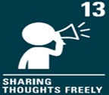 | Democracy - People who strike have decided to take action to help their voice be heard. We should listen to the voice of others and remember we also have a voice and have the right to use it.
19th September | A housing association has built Europe’s first virtually plastic-free housing development in the UK. | Where might we find plastic in our homes? | 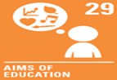 | Individual Liberty - Our actions have consequences. If we choose to buy and use items made from plastic, we must consider the impact this will have on our world.
26th September | Pakistan has had the heaviest rainfall in decades. The United Nation's (UN) Secretary General has urged the world to help Pakistan, after floodwater covered a third of the country. | Who are the people who help us? |  | Individual Liberty - Millions of people living in Pakistan have been affected by flooding. There are many different ways we can help if we choose to.
3rd  October | The popular dance competition, Strictly Come Dancing, has returned to TV screens. | What competitions do you enjoy? |  | Rule of Law - Competitions have rules. Rules are there to help make competitions fair and safe for everyone who enters.
10th  October | For over 20 years, Serena Williams and Roger Federer have dominated tennis tournaments all over the world. Between them, they have won 43 Grand Slam titles. | What would you like to be ‘the best’ at? | 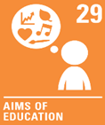 | Mutual Respect and Tolerance - Everyone is different, with different talents. We can respect and celebrate the achievements of others and be thankful for the people in our lives who do the same for us.
17th  October | All Lidl chocolate bunnies are to be melted after chocolate maker, Lindt, said they looked too similar to their own bunny shaped chocolate treat. The Federal Supreme Court | Can we learn from our mistakes? | 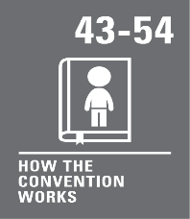 | Individual Liberty - Our actions all have consequences. We must consider these consequences and take responsibility for our actions and the choices we make.

