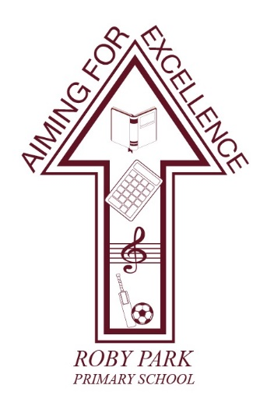

Roby Park Primary School

Easton Road

Huyton

Knowsley

L36 4NY

Tel: 0151 477 8340

Website: www.robyparkprimary.co.uk

E-mail: robypark@knowsley.gov.uk

Headteacher: Mrs K Allen

Tuesday 11th July

KS2 SATs Results

Dear Parents/Carers,

Please find your child’s KS2 SATs results enclosed for the English grammar, punctuation, vocabulary and spelling test, English Reading and Mathematics tests. The results will show your child’s test raw score followed by the scale score and then it states whether they have not achieved the standard or achieved the standard.

You will also find teacher assessments for English Writing and Science as the children do not sit tests for these curricular areas. Again, the report will state whether they have achieved or not achieved the standard.

Please see the table below to put our results into context:

Subject | Roby Park’s Results  % of children achieving the expected standard_ | National Results  % of children achieving the expected standard_
Reading | 83% | 73%
Writing | 83% | 71%
Maths | 75% | 73%
GPVS | 79% | 72%
RWM combined | 75% | 59%

We are exceptionally pleased to inform you that we are above national in all areas which is an incredible achievement.

We are extremely proud of the determination, resilience and effort of all of our children over the past academic year.
Whether your child has or hasn’t achieved the expected standard, the results do not reflect how unique, talented and special all of our children are, as we have said previously. Whilst these tests measure knowledge and skills in English and Maths, they do not measure courage, compassion, happiness, confidence or kindness which are far more important.

Warmest regards,
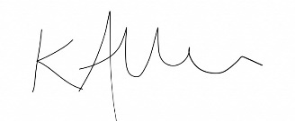
Mrs Kat Allen
Headteacher

