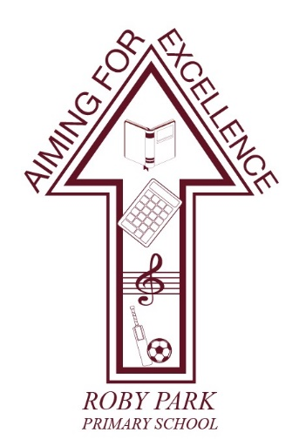

Roby Park Primary School

Easton Road

Huyton

Knowsley

L36 4NY

Tel: 0151 477 8340

Website: www.robyparkprimary.co.uk

E-mail: robypark@knowsley.gov.uk

Headteacher: Mrs K Allen

Date: Monday 5th June 2023

Community Spirit Festival – Tuesday 13th June 2023

Dear parents/carers,

In memory of Olivia Pratt Korbel, the children in the local area (St Margaret Mary’s Infant and Junior School, Malvern and Roby Park) have been working collaboratively on some joint projects (Art, Gardening, Choir and Media Arts).

To celebrate what would have been Olivia’s 10th birthday we would like to invite all our families to a special event ‘The Community Spirit Festival’ on Tuesday 13th June to showcase this work.

The event will commence at 5.30pm. Families should gather at the bandstand of the Cricket Club at Court Hey Park where, together with the other schools involved, they will take part in a walk around the park followed by a showcase of some of the work produced.

This event will be filmed by Channel 4 and extracts may be used for a forthcoming documentary. All children MUST be accompanied by an adult.

The event should be a very memorable one and one which brings the community together to celebrate Olivia’s life. We hope that as many families as possible will be able to join us on the evening.

Thank you for your continued support.
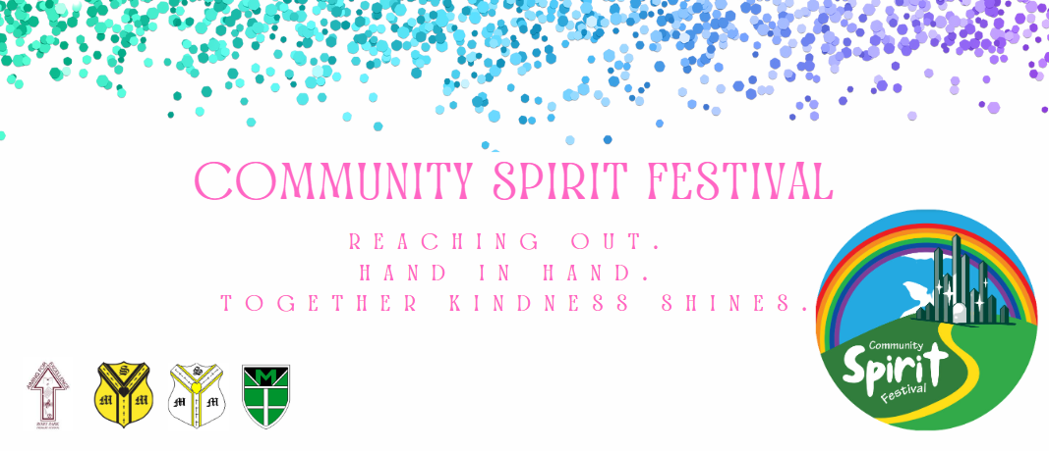
Warmest regards,

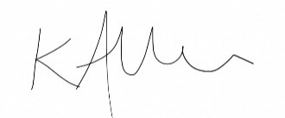

Mrs Kat Allen
Headteacher

