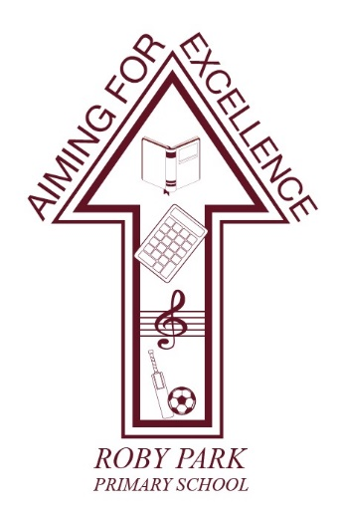

Roby Park Primary School

Easton Road

Huyton

Knowsley

L36 4NY

Tel: 0151 477 8340

Website: www.robyparkprimary.co.uk

E-mail: robypark@knowsley.gov.uk

Headteacher: Mrs K Allen

Monday 15th May 2023

Y1- Y6 Class End of Term Trips

Dear Parents/Carers

We are excited to inform you we have arranged exciting end of year class trips taking place in June and July. Trips organised are as follows:

Class | Date of Trip | Trip | Cost | Payment Deadline
YN | Tuesday 20th June | Farmer Ted’s | £17.25 | Friday 16th June
YR
Y1 | Monday 19th June | Smithills Animal Farm | £17.00 | Friday 16th June
Y2 | Wednesday 21st June | Bubbles Soft Play & New Brighton Beach | £18.50 | Monday 19th June
Y3 | Friday 30th June | BeWilderwood | £18.00 | Wednesday 28th June
Y4
Y5 | Thursday 22nd June | West Kirkby Beach & Watersports | £26.00 | Monday 3rd July
Y6 | Friday 14th July | Chester Zoo | £18.00 | Tuesday 11th July

Lunches
Please provide a healthy packed lunch and bottle of water for your child. Children who are eligible for Free School Meals will receive a packed lunch provided for them.

Payments
The cost for the class trips varies depending on location and are detailed in the above table. The school is also subsidising the trip by contributing towards the cost of the coaches for all class visits.

Parents/carers can either pay the balance in full; make instalments of your choice or pay 4 weekly instalments but all balances must be settled by the payment deadline.

Pocket Money
If parents/carers want to provide children with pocket money for the shops (YN, YR, Y1, Y3, Y4, Y6) or for ice creams (Y2, Y5), this is optional and no more than £10 please.

Warm regards
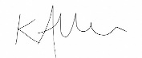

Mrs Kat Allen
Headteacher

