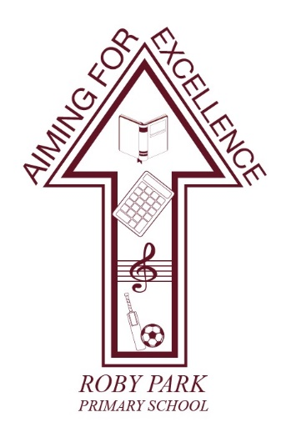

Roby Park Primary School

Easton Road

Huyton

Knowsley

L36 4NY

Tel: 0151 477 8340

Website: www.robyparkprimary.co.uk

E-mail: robypark@knowsley.gov.uk

Headteacher: Mrs K Allen


Wednesday 22nd March

Easter Disco

Dear Parents/Carers

On Thursday 30th March, we will be holding our Easter discos.

We will end the day, with our fabulous Easter discos. Nursery and Reception will enjoy their disco from 2.00-3.00pm during the school day. Y1 & Y2 will have their disco at 3-4pm with Y3 – Y6 having their disco 4.15 – 5.15pm. Nursery, Reception and KS1 can come to school in their party clothes. KS2 will wear their uniform.

Nursery children who do not attend school in the afternoons but wish to come to the disco, can stay in school for the afternoon and will need a packed lunch.

The cost of the disco for Nursery – Y2 children is £2.00 and includes a small packet of sweets, crisps and a drink. The cost of the disco for Y3 – Y6 is £2.00 and children get a chip cone and they can bring extra money to buy sweets, drinks and crisps. There is also limited glow items. We are no longer providing chips to Early Years and KS1, as they are not eaten. The disco must be paid for on Parent Pay by Wednesday 29th March.

All children in Nursery – Y2 should be picked up from their classroom door at the end of their discos as normal. KS2 children should be collected from the main playground by an adult at 5.15pm. KS2 children must be brought to school for the disco by an adult and the adult must wait for children to have gone through the double red doors before leaving.

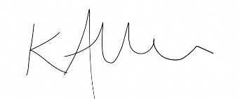
Yours faithfully
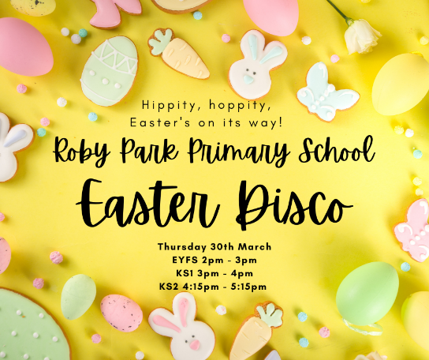

Mrs Kat Allen
Headteacher

