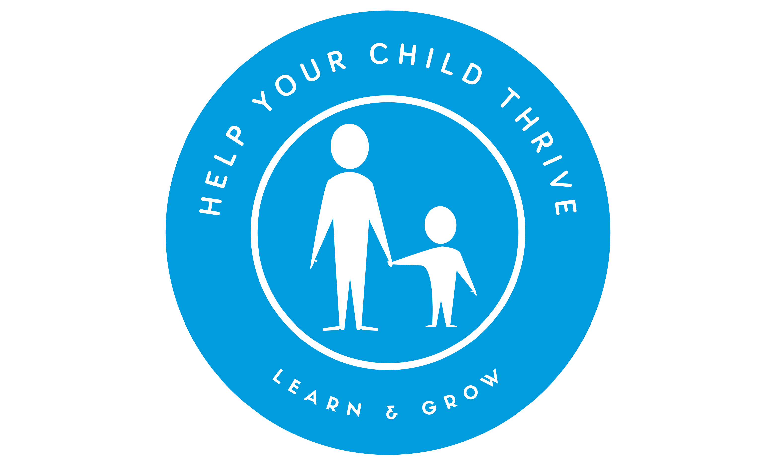

Dear Parent/Grandparent/Carer,

The ‘Help Your Child Thrive’ programme is coming to Roby Park Primary School on Tuesday 28th February to help you help your child thrive at school. This 6 session course runs for an hour or so in school just before you pick your child up. I’ll have the kettle on at 1.45pm!

The course gives you a real insight into what your child will be learning at school and how they are being taught. Each week you’ll receive lots of practical tips and ideas as to how to help your child continue to develop skills in oracy, reading, writing, maths, confidence and resilience. The course is a great way to gain tips about supporting your child’s well- being too. You will be given a booklet full of resources and ideas for games to play with your child at home which helps them embed what they have learnt in school. The course is also a good chance to meet other parents and share ideas with them. Parents who have done the course say they have noticed a big difference in their confidence in being able to support learning at home..

The course is open to all parents/grandparents/carers of year 3 & 4. However, places are limited at this time to 10 parents so be quick to respond! Don’t worry if you can’t make all 6 sessions as a friend could stand in for you if needed.

If you’d like to sign up for the course, please fill in the details by clicking on the link below or returning this form completed to your child’s class teacher. We look forward to seeing you! https://forms.gle/ygYK73c4cymFmEBe8

Child’s Name:

Parent’s Name:

Email address:

Parents/carers will be notified if they have a place on Friday 24tj February.

What parents have said about the course……..
“I had no confidence helping my child with maths. Now I know exactly how maths is taught so I can help her. I was taught in a completely different way!”

“Loved seeing my son’s confidence grow as a result of me being able to help him more with his work at home”

