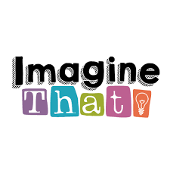
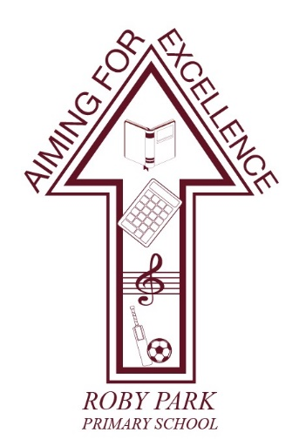

Roby Park Primary School

Easton Road

Huyton

Knowsley

L36 4NY

Tel: 0151 477 8340

Website: www.robyparkprimary.co.uk

E-mail: robypark@knowsley.gov.uk

Headteacher: Mrs K Allen
Friday 6th January 2023

YR Class Science Trip to Imagine That!

Dear Parents/Carers

We are excited to inform you we have arranged an exciting trip to Imagine That! Science Discovery Centre.

Children will be travelling to and from Imagine That by minibus during school hours. They will need to wear full school uniform and a warm, waterproof coat.

Please provide a healthy packed lunch for your child. Children who are eligible for Free School Meals will receive a packed lunch provided for them.

The cost for the visit is £8.50 per child. The school is subsidising the trip by paying for the transport for the class visit.

Parents/carers can either pay the balance in full; make instalments of your choice or pay 5 weekly instalments of £1.70 starting on Fri 13th January through to Friday 10th February.

In order to provide the option of instalment payments, we have had to put an end date in of 10th February. This is not your child’s trip date but the deadline date for payment. Your child’s trip date is to be confirmed however we anticipate it will be Tuesday 14th March and it will be confirmed this week.

If you would like to accompany us as a parent helper, please contact the office and we will confirm parent helpers in the coming weeks.

Warm regards

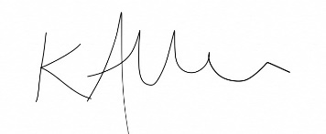

Mrs Kat Allen
Headteacher

