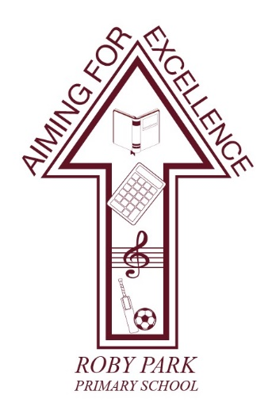

Roby Park Primary School

Easton Road

Huyton

Knowsley

L36 4NY

Tel: 0151 477 8340

Website: www.robyparkprimary.co.uk

E-mail: robypark@knowsley.gov.uk

Headteacher: Mrs K Allen
Friday 6th January 2023

Y1- Y6 Class Science Trips to the Catalyst Museum this Term

Dear Parents/Carers

We are excited to inform you we have arranged exciting workshops for Y1 – Y6 at the Catalyst Museum this term. Children will enjoy a workshop followed by an exploration of the Interactive Gallery which houses a range of brand new, hands-on exhibits allowing them to: investigate science and technology; film in the TV studio; test the scarf shooter; make an animation or create a marble run.

Children will be travelling to and from the Catalyst Museum by minibus during school hours. They will need to wear full school uniform and a warm, waterproof coat

Please provide a healthy packed lunch for your child. Children who are eligible for Free School Meals will receive a packed lunch provided for them.

Class | Date of Trip | Workshop Focus
Y1 | Weds 1st Mar | Soap Suds: This amazing workshop teaches children the history of soap and how soap is made. They then make their own bar of perfumed and coloured soap.
Y2 | Tues 14th Mar | Solids, Liquids & Gases: Pupils see some exciting and unfamiliar solids, liquids and gases with an emphasis on ‘wow’ science and spectacular demonstrations
Y3 | Thurs 23rd Mar | Light: This amazing workshop explores concepts such as; white light is a mixture of colours with demonstrations using prisms and ‘laser specs’, the formation of shadows, and different sources of natural and man-made light
Y4 | Thurs 16th Mar | Solids, Liquids & Gases: Pupils learn about different materials and their properties in this spectacular show using liquid nitrogen and solid carbon dioxide.
Y5 | Tues 28th Feb | Making Medicine: This amazing workshop allows children to take on the role of a development chemist, make and test different medicines while practising their scientific enquiry skills
Y6 | Fri 24th Mar | Light: This amazing workshop explores concepts such as; white light is a mixture of colours with demonstrations using prisms and ‘laser specs’, the formation of shadows, and different sources of natural and man-made light (including demonstrations using UV light, fluorescent lamp, fibre optics and glow-in-the-dark objects.

The cost for the workshop and visit to the Museum is £8.50 per child. The school is subsidising the trip by paying for the transport for all class visits.

Parents/carers can either pay the balance in full; make instalments of your choice or pay 5 weekly instalments of £1.70 starting on Fri 13th January through to Friday 10th February.

In order to provide the option of instalment payments, we have had to put an end date in of 10th February. This is not your child’s trip date but the deadline date for payment. Your child’s trip date is stated above.

Warm regards

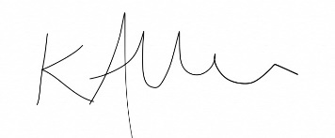

Mrs Kat Allen
Headteacher

