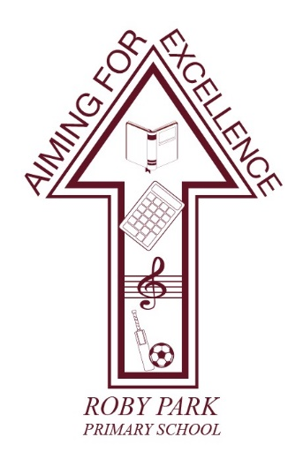

Roby Park Primary School

Easton Road


Huyton

Knowsley

L36 4NY

Tel: 0151 477 8340

Website: www.robyparkprimary.co.uk

E-mail: robypark@knowsley.gov.uk

Headteacher: Mrs K Allen

Date: Monday 30th January

Valentine’s Disco

Dear Parents/Carers

On Thursday 9th February, children can come to school dressed in their party clothes (or whatever they are most comfortable in).

We will end the day, with our fabulous Valentine’s discos. Nursery and Reception will enjoy their disco from 2.00-3.00pm during the school day. Y1 & Y2 will have their disco at 3-4pm with Y3 – Y6 having their disco 4.15 – 5.15pm.

The cost of the disco for Nursery – Y2 children is £3.00 and includes a chip cone, sweets, drink and glow surprise. The cost of the disco for Y3 – Y6 is £2.00 and children get a chip cone and they can bring extra money to buy sweets and glow toys. Disco tickets can be purchased from the office as of Tuesday 31st January.

All children in Nursery – Y2 should be picked up from their classroom door at the end of their discos as normal. KS2 children should be collected from the main playground by an adult at 5.15pm. KS2 children must be brought to school for the disco by an adult and the adult must wait for children to have gone through the double red doors.

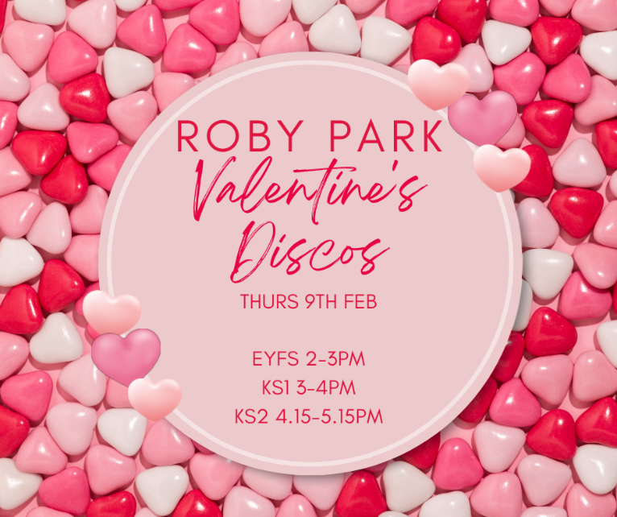
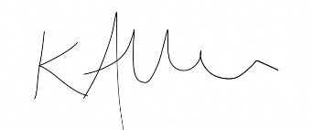
Yours faithfully

Mrs Kat Allen
Headteacher

