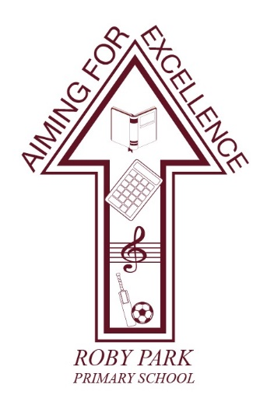

Roby Park Primary School

Easton Road

Huyton

Knowsley

L36 4NY

Tel: 0151 477 8340

Website: www.robyparkprimary.co.uk

E-mail: robypark@knowsley.gov.uk

Monday 23rd January 2023

Industrial Action National Ballot – Roby Park
Dear Parents/Carers

We have received confirmation that the National Education Union (NEU) have asked their membership to take part in strike action in relation to a dispute regarding pay and working conditions.

As a result, we have received notification that some staff in our school will be taking part in strike action on:

- Wednesday 1st February
- Tuesday 28th February
- Wednesday 15th March
- Thursday 16th March

Having carefully reviewed the implications of the strike on our staffing levels, we have taken the decision to close the school on the dates above. Parents are therefore asked to make alternative arrangements on this day and pupils should not report to school.
I apologise for any inconvenience this may cause. The school will re-open as normal on:
- Thursday 2nd February
- Wednesday 1st March
- Friday 17th March

Warm regards

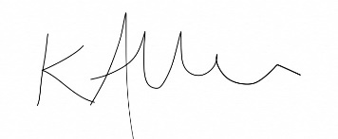

Mrs Kat Allen
Headteacher

