

Roby Park Primary School

Easton Road

Huyton

Knowsley

L36 4NY

Tel: 0151 477 8340

Website: www.robyparkprimary.co.uk

E-mail: robypark@knowsley.gov.uk

Headteacher: Mrs K Allen

Date: Thursday 24th November 2022

Y5 Staffing Changes After Christmas

Dear Parents/Carers

I am writing to inform you that Mrs Cooke will be leaving us at Christmas. Mrs Cooke has been a teacher for over 9 years at Roby Park. She has been a fantastic member of our team, most recently leading KS1 and being responsible for leading Geography & History across our school with great enthusiasm.

Mrs Cooke will be greatly missed by all of us here at Roby Park and we wish her the best of luck in her new ventures.

With the departure of Mrs Cooke, we are writing to inform you Mr Swatman has successfully been promoted as our new Key Stage 1 lead and therefore he will be our new Y2 teacher as of January.

As a result of Mr Swatman’s successful appointment as KS1 Leader of Learning and Y2 teacher, we are restructuring our staffing meaning Mr Couling will be our new Y3 teacher as of January. This means that Y5 will be brought back together as a whole class with Miss Worthington, Mrs Kildare and Mrs Mills.

We have been very fortunate that the children have been able to be taught in smaller teaching groups for the past 12 months and as a direct result of the progress made, both academically, socially and emotionally, we are now in a position where they can learn and thrive together. By bringing the class back together, this readies them for Y6 and their transition into secondary school.

Over the coming weeks, Y5 will engage in transition activities with Miss Worthington so there will be a smooth start to the new year.

Please feel free to come and introduce yourselves to Miss Worthington who will be on our main playground at the end of each day.

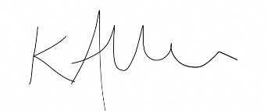
Yours faithfully

Mrs Kat Allen
Headteacher

