

Roby Park Primary School

Easton Road

Huyton

Knowsley

L36 4NY

Tel: 0151 477 8340

Website: www.robyparkprimary.co.uk

E-mail: robypark@knowsley.gov.uk

Headteacher: Mrs K Allen

Date: Thursday 24th November 2022

Y3 Staffing Changes After Christmas

Dear Parents/Carers

I am writing to inform you that Mrs Cooke will be leaving us at Christmas. Mrs Cooke has been a teacher for over 9 years at Roby Park. She has been a fantastic member of our team, most recently leading KS1 and being responsible for leading Geography & History across our school with great enthusiasm.

Mrs Cooke will be greatly missed by all of us here at Roby Park and we wish her the best of luck in her new ventures.

With the departure of Mrs Cooke, we are writing to inform you Mr Swatman has successfully been promoted as our new Key Stage 1 lead and therefore he will be our new Y2 teacher as of January.

As a result of Mr Swatman’s successful appointment as KS1 Leader of Learning and Y2 teacher, we are restructuring our staffing meaning Mr Couling will be our new Y3 teacher as of January. Mr Couling is a wonderfully experienced teacher who the children are familiar with and he is adored by children across the school so we believe there is an exciting change for Y3 and Mr Couling alike.

Over the coming weeks, Y3 will engage in transition activities with Mr Couling so there will be a smooth start to the new year.

Mrs Woolley and Mrs Bomba-Bennett will remain in Y3 also, working alongside Mr Couling.

Please feel free to come and introduce yourselves to Mr Couling who will be on our main playground at the end of each day.

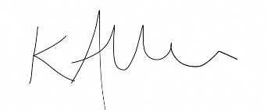
Yours faithfully

Mrs Kat Allen
Headteacher

