

Roby Park Primary School

Easton Road

Huyton

Knowsley

L36 4NY

Tel: 0151 477 8340

Website: www.robyparkprimary.co.uk

E-mail: robypark@knowsley.gov.uk

Headteacher: Mrs K Allen

Date: Thursday 24th November 2022

Y2 Staffing Changes After Christmas

Dear Parents/Carers

I am writing to inform you that Mrs Cooke will be leaving us at Christmas. Mrs Cooke has been a teacher for over 9 years at Roby Park. She has been a fantastic member of our team, most recently leading KS1 and being responsible for leading Geography & History across our school with great enthusiasm.

Mrs Cooke will be greatly missed by all of us here at Roby Park and we wish her the best of luck in her new ventures.

We are excited to inform you Mr Swatman has been promoted as our new Key Stage 1 lead and therefore he will be our new Y2 teacher as of January. Mr Swatman is an experienced Key Stage 1 practitioner and has been a wonderful addition to our team since joining us in September.

Over the coming weeks, Y2 will engage in transition activities with Mr Swatman so there will be a smooth start to the new year.

Mrs Kinsella, Mrs Marnell & Miss Johnson will remain in Y2 also, working alongside Mr Swatman.

Please feel free to come and introduce yourselves to Mr Swatman who will be on our main playground at the end of each day.

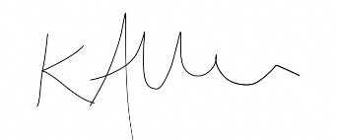
Yours faithfully

Mrs Kat Allen
Headteacher

