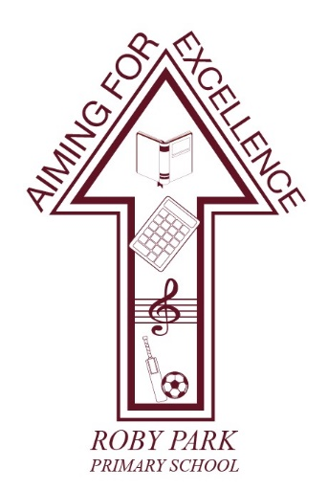

Roby Park Primary School

Easton Road

Huyton

Knowsley

L36 4NY

Tel: 0151 477 8340

Website: www.robyparkprimary.co.uk

E-mail: robypark@knowsley.gov.uk

Headteacher: Mrs K Allen

Date: Tuesday 1st November 2022

Christmas Cards

Dear Parents/Carers

Last half term, your children all designed a Christmas card of their own. Attached to this letter you will see your child’s card along with their design. On the order form, you will see your child’s name, class and instructions for how you can view, approve and order online.

You will be able to select Christmas cards, gift tags, wrapping paper, mugs, tea towels and eco bags all in your child’s hand drawn design.

TO make an order with of items with your child’s hand drawn Christmas design, it is really simple.
- Go to approve.myfundraisinghub.com.
- Then enter your first name, surname and email address and click next.
- Enter the organisation code and unique design code on your order form.
- Add your child’s first name and surname followed by their class from the drop-down menu.
- If you are happy, click the box to approve the design and details.
- Click to say you are happy with the design.
- You will then be taken to the offline shop. Select the items and quantities you would like to add to your cart. You will need to re-enter your organisation code and design code.
- Once happy with the items in your cart, you select check out.
- You will be taken to another page where you need to enter some details and click ‘continue to payment’
- You will not be required to pay online, just order online. You will then be required to pay cash at the office so your order can be processed.

Once you have placed your online order, we will approve the order when cash payment has been received. Please note until approved, the order will be kept on hold.

The deadline for online orders and cash payments at the office is 8th November.

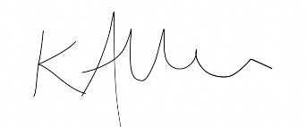
Yours faithfully

Mrs Kat Allen
Headteacher

