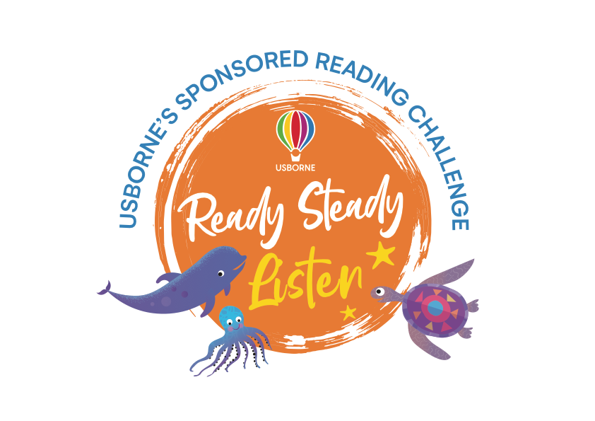
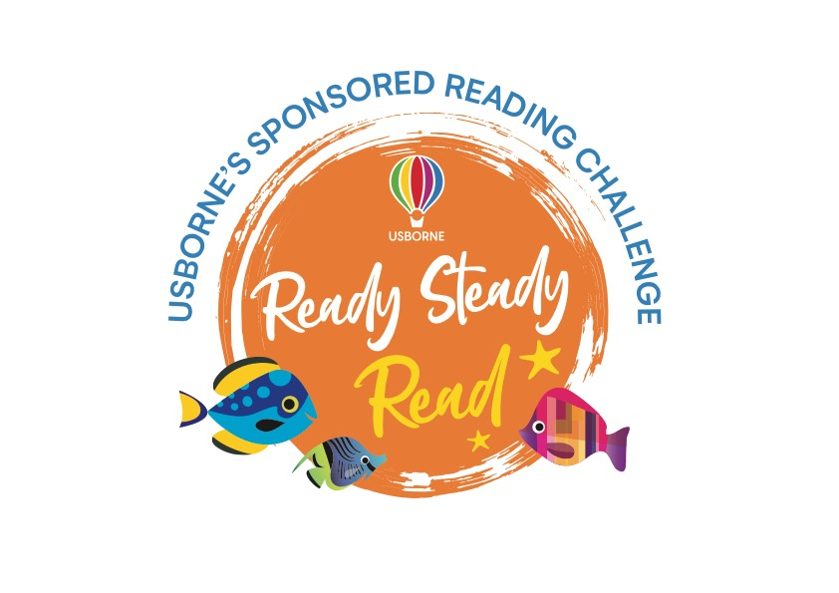

Dear Parent/Guardian,

To encourage a lifelong love of reading at home and nursery, we will be running a SPONSORED LISTEN BETWEEN 16th -23rd MARCH.

The project is being organised in conjunction with our local Usborne Partner, Emma Evans and all the money raised will go towards brand new books for our nursery. In addition to the sponsorship money, Usborne will also donate up to 60% of the total raised in EXTRA FREE BOOKS to the nursery.

Please help us to enhance our reading resources by encouraging your child to spend a small amount of time each day listening to stories being read aloud, either by you, a family member or one of our team.

If you are able to support our sponsored listen, please find enclosed a sponsorship form and listening log for your child if they wish to use it to record their listening.

After the sponsored listen, please send all the sponsorship money your child has raised to the nursery by 30th March. Cash & cheques are accepted, and cheques should be made payable to Emma Evans.

We look forward to having lots more books for your child to read, share and enjoy.

Sponsorship Form

Pupil name: Class:

Name | Sponsorship  (per minute/per book or total donation) | Amount collected

Please return this form along with your sponsorship money and reading log to the school office by 30th March

Total amount:

Listening Log

Name: Class:
Day | Minutes listened/number of books listened to | Total

Total minutes listened/number of books listened to:

