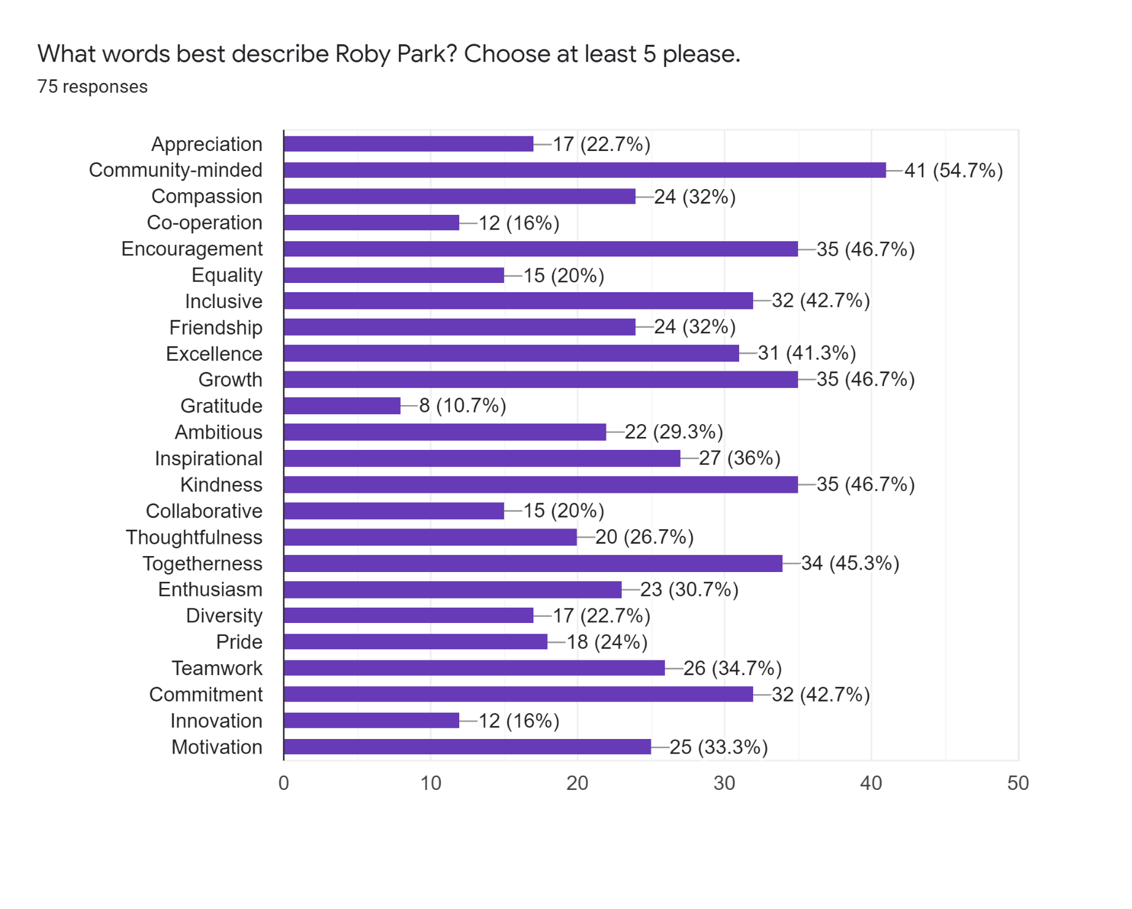

In your own words, what do you love about our Roby Park Community?
- Every child is equal, every child is encouraged and supported to reach their full potential. Every child is at the heart of all we do.
- The growth it has shown the last few years.
- Love the way they meet children’s needs.
- Everyone is included, children, parents and local residents.
- I love the fact there are new things going on weekly. All the children look forward to each new activity. School has become a fun place to be.
- Absolutely amazing community minded school! Cannot fault a single thing about the people of Roby Park! Such a special school to be involved with.
- How much you support the children and have such a lovely happy environment. All the activities you do and include the parents aswell which the children love!
- Of course the children's education is excellent but they come together as a whole community. Nobody will go without because of the hard work and help they do to help out families.
- Staff are very nice.
- The feeling of belonging.
- It's like one big family.
- I love how much the children love coming to school and the opportunities they have in a area that does not have many.
- Lovely things done to make things better for the children for example the new playground and allotments. Here's hoping you have an gardening club as he would like to join in any weeding done I'll help too. Recent food waste project is amazing idea and you should be very proud of yourselves. My son is happy here and it shows every day.
- Fantastic - can not fault it.
- Amazing and supporting in every way.
- I love that everyone I have met have shown respect, kindness and support regardless of colour, religion and ethnicity. I also love and appreciate staff go above and beyond for the kids to ensure they have a happy and memorable time at school - thank you!
- I love the way the school let me get involved in my daughter’s learning. I also love how they make learning so much fun for the early learning years.
- Literally everything! I am so happy my daughter comes to your school. The confidence she has now is out of this world. I never ever thought she would stand up in a play or go to dance or gymnastics then come home and show us what she has done. Unbelievable it is, every single day there is something new from you guys and lots of themed days. Absolutely love it, everyone I tell says they should have put their children in your school or will be applying for their little ones. THANK YOU XXXX
- I’m so impressed with everything to do with this school. My two daughters were so unhappy going to school before they attended Roby Park. Now they skip in 😀. There’s always something going on to involve all the children’s and parents so you always feel included in everything that’s going on. I appreciate everything that’s organised for the children and family as the planning that goes into must be endless and it’s never unnoticed by us. Also it’s not just the events that get planned it’s all the thoughtfulness that’s put in to everything that it makes that extra special for the children and families. Honestly I could go on and on 🤣 My children and our family have never been happier - keep up all your amazing work.
- I love that our school is supportive and the staff are approachable, kind and thoughtful. I love how there is always something exciting going on for the children to look forward to.
- I think all the staff and children are all lovely.
- I love how new things are always being trialled as a way of helping the children. They always think of fun things and events which will help make education fun and keep them engaged.
- I love that the children can freely express themselves with support from all adults. They stretch and challenge pupils to get the best out of them.
- How much you care about the community and the children even when they're not in school.
- School spirit, accessible teachers makes it feel like they care, i.e each teacher knows the children and are happy to tell parents about their day or things they have been up to. Helps parents feel part of the school and part of the learning process.
- Everyone is valued.
- I love how committed every person in the Roby Park Community is to giving each child the best opportunity to grow.
- Everyone is valued and the children come first always
- I love how the staff and parents all work together to do what is best for the children. It is inclusive to all. Children are happy and enjoy school.
- How welcoming it is and how committed the staff are to helping, encouraging and nurturing the children.
- How much effort is put in to things planned for the children and parents.
- The opportunities that are provided to all children and that parents/carers are able to take part in many of them.
- Roby Park brings out the best in our children and I love how they involve us parents as much as they can.
- My kids enjoy going there and that's what matters, and my son enjoys history lessons.
- I love how the school tries hard to make sure children have unique experiences to enrich their lives. The school try to include families in all aspects of school life and it is such a wonderful school.
- How everyone gets involved.
- Happy, friendly staff.
- The family feel the good factor.
- The way the school has moved forward and always puts the children first. The inclusion of families and the community.
- I have always been proud of the way they care for and nurture our children. Encouraging them to be open and honest and helping them to believe in themselves.
- How it is like a family, welcoming all and celebrating all.
- That we are unique.
- I love that it’s doesn’t matter how big or small.
- The problem is there always willing to help xx
- The staff and people.
- The respect and commitment between staff and pupils. It’s a very happy school.
- All children are valued and are at the centre of everything we do.
- The best school with the best teachers, my little girl loves to go every day.
- And every day she surprises me with something new she learned. Thank you very much!
- Roby Park has a kind and welcoming atmosphere. Every child is important and treated as an individual.
- I love that the children are at the heart of everything we do. We know they are incredible and we strive to instill that belief in them. We aim to give them a sense of self and how they fit in the community. We celebrate everything they do and encourage them to aim for better things but most of all we want all our children enjoy their time with us and be able to share that with their loved ones in so many different ways.
- Warm, honest, helpful, caring, go-the-extra-mile team of staff who seem to be genuinely happy and love their jobs.
- How all staff have made my daughter feel welcome, cared for and shown nothing but kindness and reassurance to us as a family.
- Just like a family ❤️
- Everyone are always thought about and included in everything!
- As parents of a child who has had problems settling in and making friends we love that the school was so understanding, caring and so quick to help us and listen to our concerns. We couldn't be happier with Roby Park.
- Everyone is equal.
- I love the family feel of the school.
- I love that my children love to go to school everyday ❤️
- I love how likeable and enthusiastic the teachers are. There’s loads of activities and opportunities for the parents to get involved. My child loves going to school every day as there is a nice atmosphere and they enjoy learning as the teachers make everything as fun as possible.
- Being a new parent I can honestly say the staff have made us feel so welcome. The children have settled in better than I could have hoped for. That is all down to the way they have been treated and welcomed into Roby Park. Thank you all!
- All the staff work together to make the school wonderful Roby Park accepts all and are always trying to make it even more outstanding for the children the work with parents amazing. They should be so extremely proud of themselves for all the work and effort they put into the school each and every day.
- I love how Roby Park build confidence in the children and how everyone works as team.
- I love that Roby Park still tries to remain a family school.
- The dedicated all round lovely and welcoming staff make this school a place my daughter gets excited to attend. She really has come on so much already in a short space of time , the regular updates for parents is amazing and we acknowledge this is all extra work for staff on top of caring, supporting and teaching for all the students! So a big thank you for all your hard work and time to make this school a great place in the community .
- My daughter is so happy there and it is a great school.

