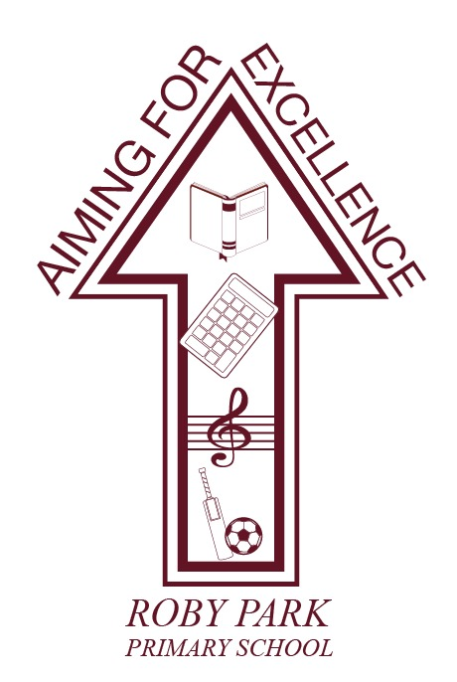

Roby Park Primary School

Easton Road

Huyton

Knowsley

L36 4NY

Tel: 0151 477 8340

Website: www.robyparkprimary.co.uk

E-mail: robypark@knowsley.gov.uk

Headteacher: Mrs K Allen

3rd November 2021

Dear Parents/Carers,

Christmas Cards

You should have received your child’s Christmas card design yesterday. Please follow the instructions on how to order. If you would like to place an order, please complete and return the order form together with the correct money as soon as possible. We are unable to open orders in the office or give change.

Please note that we cannot accept any orders after 9.00 a.m. on Friday, 12th November.

Yours faithfully

Kat Allen
Headteacher


