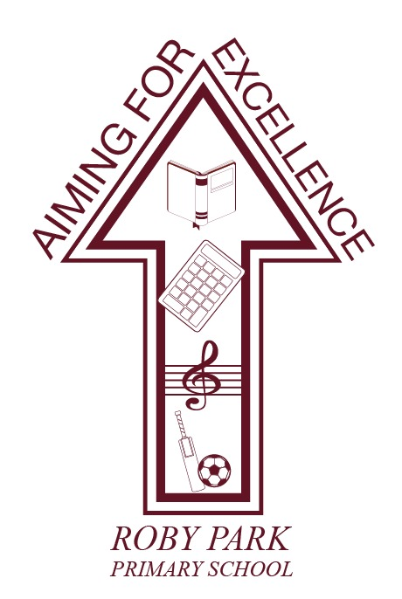

Roby Park Primary School

Easton Road

Huyton

Knowsley

L36 4NY

Tel: 0151 477 8340

Website: www.robyparkprimary.co.uk

E-mail: robypark@knowsley.gov.uk

Headteacher: Mrs K Allen

Dear Parents/Carers

Come and join us for Christmas Family Dining!

Our popular family dining days are back! Lorraine (our school cook) and her team are planning to cook Christmas lunch for everybody. The children and I would like to invite you to come and join us for lunch. The idea is simple; we think that our school dinners are fantastic and we want to encourage some festive family time at Roby Park!

So for one day, we are inviting parents/carers etc, to come into school and have Christmas lunch with their child. Even if your child normally has packed lunch, why not have a change for one day? We will have our dining tables organised for the day and will try to make the dining hall as relaxing as possible, with decorations, a Christmas feast and crackers.

During this week, there will only be sandwiches and jacket potatoes available every day, as the kitchen will obviously struggle to cook and prepare several hundred Christmas lunches as well as offering a varied menu.

Please note: Service will begin at 11:00am prompt each day. The dates arranged are as follows;

Nursery & Reception families | Monday 13th December @ 11.00am
Y1 & Y2 families | Tuesday 14th December @ 11.00am
Y3 & Y4 families | Wednesday 15^{h} December @ 11.00am
Y5 & Y6 families | Thursday 16th December @ 11.00am

Christmas meals cost £2.10 per child which needs to be paid via Parent Pay. Adult meals cost £5.50 which will also be added to Parent Pay and must be paid by 3rd December at the latest. Each pupil can have up to two adults. If your child wishes to have Christmas dinner but adults will not be attending, they can sit with their friends and families. If they would prefer not to have Christmas dinner, they will have lunch as normal. If your child prefers to have a packed lunch, they may do so and you can still book to have lunch with them. Our Christmas Dining days are taking place across 4 consecutive days for different year groups. Because of the disruption that would be caused to the curriculum across these 4 days, unfortunately we cannot offer the usual arrangement of inviting siblings to eat together. We appreciate that this might mean parents/carers attending more than one Family Dining day and we apologise for any inconvenience caused; however this is unavoidable.

If you would like to join us please complete the form below, ticking all the appropriate boxes and return the form to the school office by 9am on 26th November 2021 as food is ordered on this date. Unfortunately we will not be able to accommodate any late requests.

Tickets will be issued the week before, these will be required for you to present on the day of your dining.

Yours faithfully

Mrs Kat Allen
Head Teacher

Child’s Name: ______________________________ Year Group: _________________________

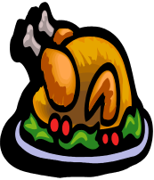 | Yes | No
My child will have a packed lunch as normal and does not want a Christmas dinner. |  | 
My child is school dinners and wants a Christmas dinner and I will pay £2.00 via Parent Pay

We would like to take part in the family dining day on;
Monday – Nursery & Reception (please circle)
Tuesday – Y1 & Y2
Wednesday – Y3 & Y4
Thursday – Y5 & Y6

 | Turkey option | Veg option
The number of adults coming to lunch is: 1 / 2 (please circle)
I confirm that I will make the appropriate payment via Parent Pay

Please select whether your child wants a turkey or vegetarian option:

Please select the number of adult turkey or vegetarian options:

