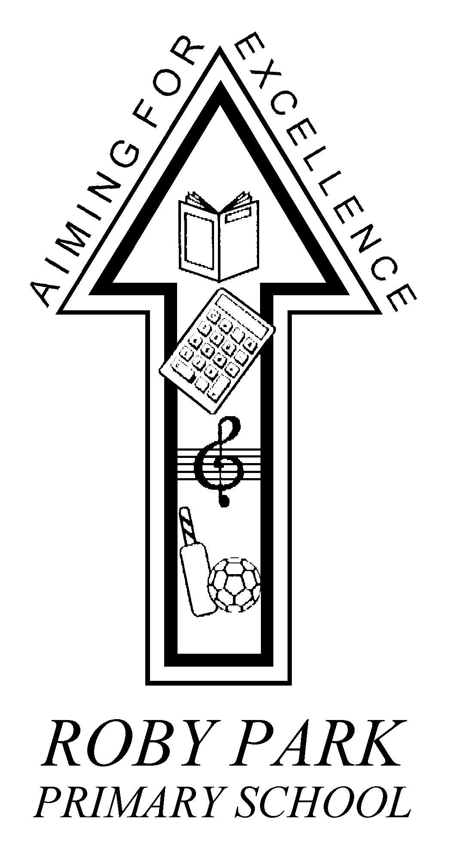

Roby Park Primary School

Easton Road

Huyton

Knowsley

L36 4NY

Tel: 0151 477 8340

Website: www.robyparkprimary.co.uk

E-mail: robypark@knowsley.gov.uk

Headteacher: Mrs K Allen

Date: Friday 3rd September 2021

Dear Parent/Carer,

COVID19 Information

We are writing to notify you of a confirmed case(s) of coronavirus in your child’s class.

Please read the following guidance carefully.

If your child is a close contact of a positive case you will be contacted by NHS Track and Trace. School no longer identifies close contacts and children do not need to self-isolate who have been close contacts.

Track and Trace will ask close contacts to get a PCR test as quickly as possible. They will not ask you to self-isolate or to stay away from school unless you have tested positive on a PCR test.

If your child is well, you do not need any specific treatment, or to change what you are doing. However, like anybody else during this current situation, you are being asked to monitor your own health, looking out for any symptoms such as cough or fever.

What symptoms should I be concerned about?

You should look for any of the following symptoms:
- new continuous cough
- fever (a temperature of 37.8°C or higher)
- loss of, or change in, normal sense of taste or smell (anosmia)

If your child develops these symptoms, however mild, at any point they need to isolate, which includes staying off school. You can arrange for your child to be tested via NHS UK or by contacting NHS 119 via telephone if you do not have internet access.

If the test is positive, your child would need to self-isolate for 10 days since the date of onset of symptoms. The rest of the household would not need to self-isolate but it would be recommended that they also get tested. More information can be found at:
https://www.gov.uk/government/publications/covid-19-stay-at-home-guidance/stay-at-home-guidance-for-people-with-confirmed-or-possible-coronavirus-covid-19-infection

If the test result is negative your child can return to school. If you need to seek medical advice, seek prompt medical attention if your illness is worsening. If it’s not an emergency, contact NHS 111 online. If you have no internet access, you should call NHS 111.

If it is an emergency and you need to call an ambulance, dial 999 and inform the call handler or operator that you have coronavirus (COVID-19).

We would recommend all families consider twice weekly home testing to support the community in keeping infection rates low in Knowsley. To order an LFD test to be delivered or to find your nearest community collect or assisted testing site please go to https://www.gov.uk/order-coronavirus-rapid-lateral-flow-tests.

Warmest regards,
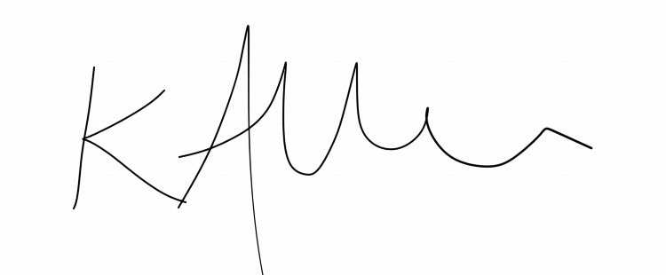
Headteacher

