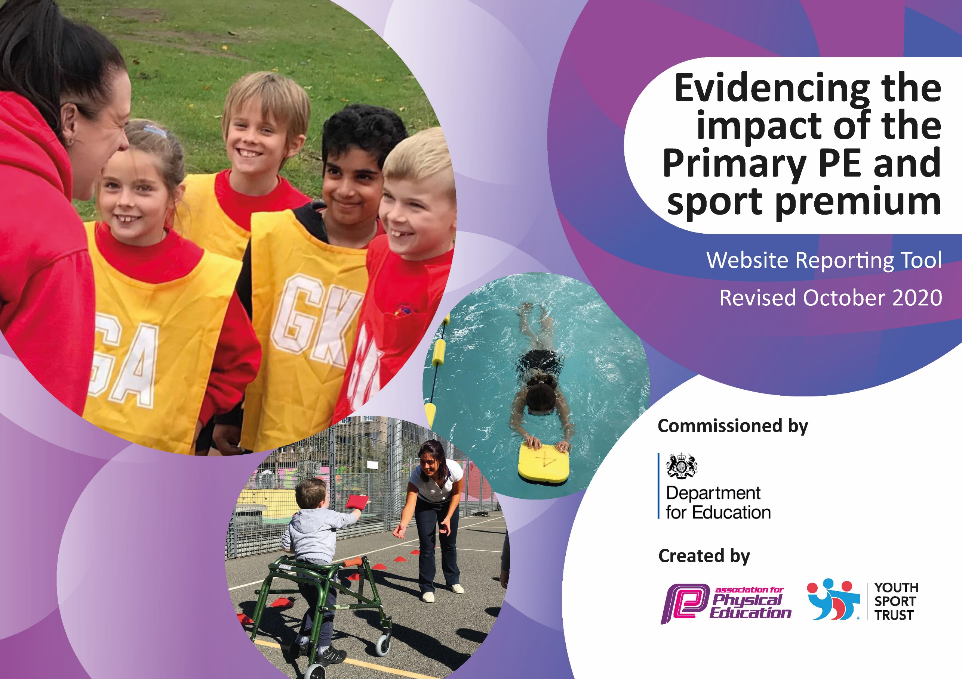
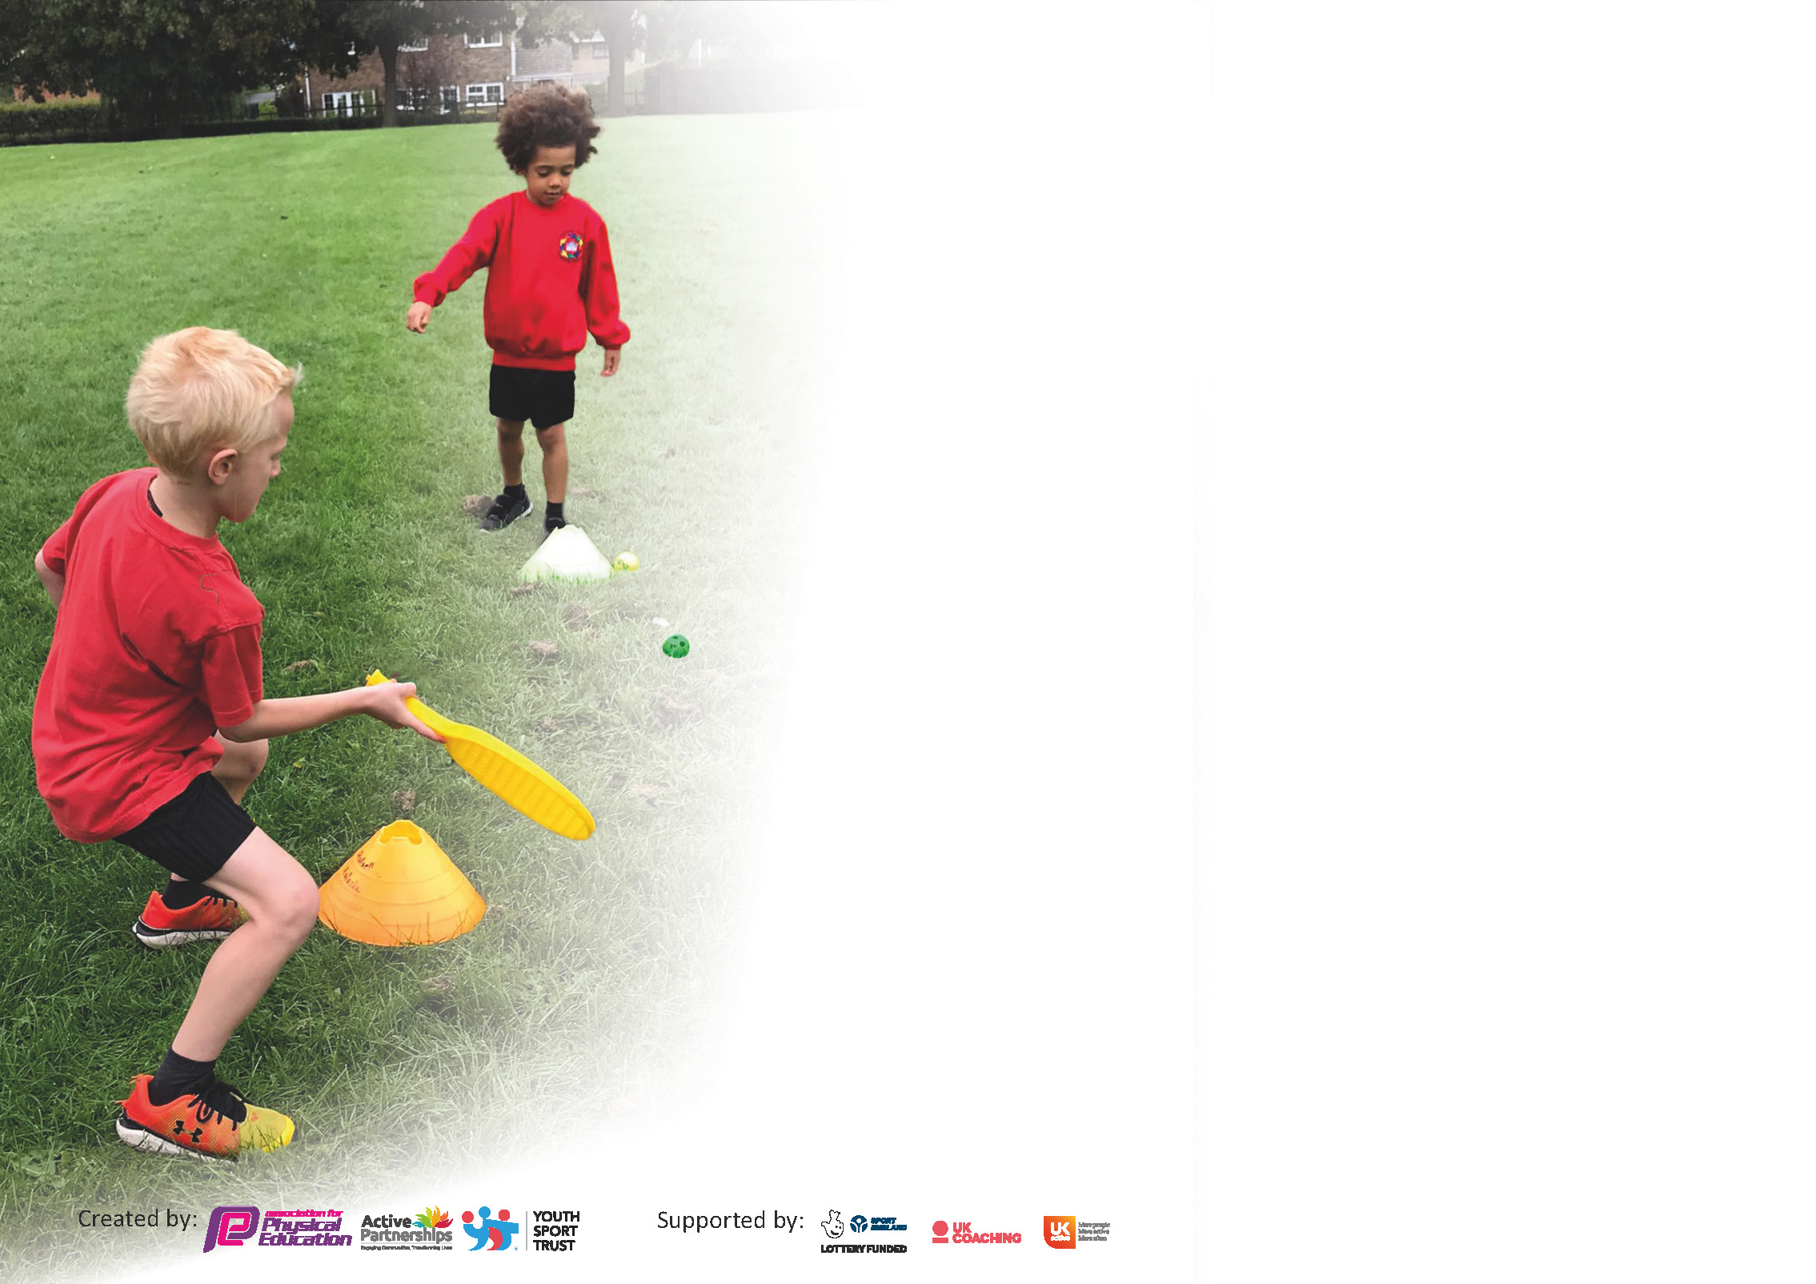

It is important that your grant is used effectively and based on school need. The Education Inspection Framework (Ofsted 2019 p64) makes clear there will be a focus on ‘whether leaders and those responsible for governors all understand their respective roles and perform these in a way that enhances the effectiveness of the school’.

Under the Quality of Education criteria (p41) inspectors consider the extent to which schools can articulate their curriculum (INTENT), construct their curriculum (IMPLEMENTATION) and demonstrate the outcomes which result (IMPACT).

To assist schools with common transferable language this template has been developed to utilise the same three headings which should make your plans easily transferable between working documents.

Schools must use the funding to make additional and sustainable improvements to the quality of Physical Education, School Sport and Physical Activity (PESSPA) they offer. This means that you should use
the Primary PE and sport premium to:

- Develop or add to the PESSPA activities that your school already offer
- Build capacity and capability within the school to ensure that improvements made now will benefit pupils joining the school in future years

Please visit gov.uk for the revised DfE guidance including the 5 key indicators across which schools should demonstrate an improvement. This document will help you to review your
provision and to report your spend. DfE encourages schools to use this template as an effective way of meeting the reporting requirements of the Primary PE and sport premium.

We recommend you start by reflecting on the impact of current provision and reviewing the previous spend.

Schools are required to publish details of how they spend this funding as well as on the impact it has on pupils’ PE and sport participation and attainment by the end of the summer term or by 31st July 2021 at the latest.

** In the case of any under-spend from 2019/20 which has been carried over this must be used and published by 31st March 2021.

We recommend regularly updating the table and publishing it on your website throughout the year. This evidences your ongoing self-evaluation of how you are using the funding to secure maximum, sustainable impact. Final copy must
be posted on your website by the end of the academic year and no later than the 31st July 2021. To see an example of how to complete the table please click HERE.
Created by: Supported by:

Please note: Although there has been considerable disruption in 2020 it is important that you publish details on your website of how you spend the funding - this is a legal requirement.
Support for review and reflection - considering the 5 key indicators from DfE, what development needs are a priority for your setting and your pupils now and why? Use the space below to reflect on previous spend and key achievements and areas for development.

N.B. In this section you should refer to any adjustments you might have made due to Covid-19 and how these will influence further improvement.
Key achievements to date until July 2020: | Areas for further improvement and baseline evidence of need:
- Daily lunchtime provision up and running increasing daily activity to 30+ minutes  - PESSPA much higher profile across the school and in the community through promotion  - New curriculum starting to be embedded with staff planning more confidently alongside the Coach  - Increased entry into competitions in line with small schools Sports Mark requirements of 10% of pupils  - Increased number of sports offered through After School Clubs, Curriculum and Competitions in line with small schools Sports Mark requirement of at least 6.  - PE higher profile with staff, more CPD offered and accessed  - PE evidenced more on Seesaw  - Values (honesty, teamwork etc.) embedded into lessons.  - Full time Coach employed by school to work closely with staff and Subject Lead to promote and support PESSPA  - Enrichment plan in place with celebration events added each half term | - Monitor the daily activity to find out and increase participation  - Baseline swimming data and identify ways to improve standards and also ways to record standards year on year (Google Drive Swimming Record File)  - Increase activity across the curriculum outside of PE lessons by baseline of active learning in Autumn Term  - Outdoor PESSPA plan upon completion of redevelopment  - Continue to develop teacher knowledge and skills to match the range of sports in the school curriculum offer - CPD  - Develop intra-school sports participation by providing variety (other than football)  - Promote the girls in football agenda through team selection and girls football pledge  - Complete School Games Mark review to be completed in the absence of Sports Mark Award this year  - Development of Remote/Blended Learning offer  - Monitor the new curriculum through SSE  - Develop B teams for future competitions  - Consistent evidence to be added to Google and Seesaw in the form of photograph and video

Did you carry forward an underspend from 2019-20 academic year into the current academic year? YES/NO * Delete as applicable

If YES you must complete the following section
If NO, the following section is not applicable to you

If any funding from the academic year 2019/20 has been carried over you MUST complete the following section. Any carried over funding MUST be spent by 31 March 2021.
Academic Year: September 2020 to March 2021 | Total fund carried over: £0 | Date Updated:
What Key indicator(s) are you going to focus on? |  |  |  | Total Carry Over Funding:
 |  |  |  | £
Intent | Implementation |  | Impact
Your school focus should be clear how you want to impact on your pupils. | Make sure your actions to achieve are linked to your intentions: | Carry over funding allocated: | Evidence of impact: How can you measure the impact on your pupils; you may have focussed on the difference that PE, SS & PA have made to pupils re-engagement with school. What has changed?: | Sustainability and suggested next steps and how does this link with the key indicators on which you are focussing this academic year?:

Meeting national curriculum requirements for swimming and water safety.

N.B Complete this section to your best ability. For example you might have practised safe self-rescue techniques on dry land.
What percentage of your current Year 6 cohort swim competently, confidently and proficiently over a distance of at least 25 metres?  N.B. Even though your pupils may swim in another year please report on their attainment on leaving primary school at the end of the summer term 2021. | 35%
What percentage of your current Year 6 cohort use a range of strokes effectively [for example, front crawl, backstroke and breaststroke]? | 35%
What percentage of your current Year 6 cohort perform safe self-rescue in different water-based situations? | 35%
Schools can choose to use the Primary PE and sport premium to provide additional provision for swimming but this must be for activity over and above the national curriculum requirements. Have you used it in this way? | Yes/No

Action Plan and Budget Tracking
Capture your intended annual spend against the 5 key indicators. Clarify the success criteria and evidence of impact that you intend to measure to evaluate for pupils today and for the future.

Academic Year: 2020/21 | Total fund allocated: £17470 of which 16697 is allocated to Sports Coach role and £1300 to KSSP | Date Updated: 9th March 2020
Key indicator 1: The engagement of all pupils in regular physical activity – Chief Medical Officers guidelines recommend that primary school pupils undertake at least 30 minutes of physical activity a day in school |  |  |  | Percentage of total allocation:
96% coach
4% KSSP
Intent | Implementation |  | Impact
Your school focus should be clear what you want the pupils to know and be able to do and about  what they need to learn and to  consolidate through practice: | Make sure your actions to achieve are linked to your intentions: | Funding allocated: | Evidence of impact: what do pupils now know and what can they now do? What has changed?: | Sustainability and suggested next steps:
- Increase activity across the curriculum outside of PE lessons  - Maintain current daily lunchtime additional sport and physical activity timetable to ensure 30+ active minutes per day  - Review further provision on completion of the outdoor development | - Complete a Heat Map analysis each term and feedback to staff. Suggest ways to make lessons more active and how they can use brain gym actively with sites such as Go Noodle  - Continue to implement the current lunchtime provision and analyse participation with Coach to adapt need  - Review the new outdoor provision to begin to incorporate activities such as the Daily Mile once work has been undertaken |  | - Heat Map analysis from Autumn Term baseline showed increased levels of activity across the curriculum from EYFS to Y3 with 30-60% of the curriculum moderately active to active (Y4-6 is much lower and activity needs boosting)  - Current 30 minutes daily activity participation (from Autumn Term) at 96%+. Non-participating pupils given individual plans for activity due to their additional needs (medical, physical, social and emotional) Spring 2 Term restricted by Lockdown and redevelopment of the outdoor limiting space (to be picked up in Summer 1)  - School Games Mark Review completed for 2020-21 in the absence of Sports Mark Award – Certification Due  - MUGA complete which will impact positively upon intra-school competition, further works ongoing | - Continue to monitor activity outside of PE lessons by completing Heat Map, adding activities such as Daily Mile once outdoor development is compete and feeding back to staff on areas where they could improve activity (Super overs, Go Noodle)  - Continue to provide and monitor all daily activity at lunch and break time to ensure the 30 minute+ activity offer is taken up by all pupils  - Utilise new outdoor areas by creating an active timetable for the areas – Daily Mile, MUGA, Yoga in Sensory area, dance in music area etc.  - Continue to keep evidence for School Games Mark in order to work towards Silver Level as soon as this reopens  - Target the least active pupils in order to provide engagement programme
Key indicator 2: The profile of PESSPA being raised across the school as a tool for whole school improvement |  |  |  | Percentage of total allocation:
Intent | Implementation |  | Impact
Your school focus should be clear what you want the pupils to know and be able to do and about  what they need to learn and to  consolidate through practice: | Make sure your actions to achieve are linked to your intentions: | Funding allocated: | Evidence of impact: what do pupils now know and what can they now do? What has changed?: | Sustainability and suggested next steps:
- Continue to promote PESSPA across the school | - Use Social Media and Seesaw to promote PE, School Sport and Physical activity  - Use lunchtime to provide additional sport and physical activity  - Promote physical activity outside of PE lessons in other areas of the curriculum  - Plan a Sports Day event for Summer |  | - PESSPA activities and events tweeted weekly and added to Facebook  - All documentation relating to PESSPA on the school website  - Lesson evidence recorded on Seesaw for Autumn Term  - PESSPA high profiled during lockdown in Spring Term with Daily Challenges in Yoga/Mindfulness, Fitness and Sport added to Seesaw alongside PE lessons  - HIIT session weekly on Social Media to promote fitness  - Lunchtime additional sports and activity had 96%+ participation in Autumn Term  - Heat Map analysis from Autumn Term baseline showed increased levels of activity across the curriculum from EYFS to Y3 with 30-60% of the curriculum moderately active to active (Y4-6 is much lower and activity needs boosting)  - KSSP Active School of the Week Awarded Spring 2 for all of our efforts during Home Learning  - Careers Week visitors identified for different sports using high profile sports people such as David Price and The Smith brothers (boxing), LFC Foundation (football), Mersey Mavericks (Basketball), Sensai Tom (Martial Arts). Alongside the sports visitors, there were also active careers visitors such as the Army, Police and Fire Service.  - Sports Day to go ahead without visitors but will impact on pupil activity levels and the competitive elements of personal best | - Continue to promote PESSPA across the school through Social Media Platforms (create a PE/Sports Twitter Account), Seesaw, Lunchtime programme, After School Clubs Programme, Enrichment Weeks/Days and Charitable events, Increased lesson activity (active learning)  - Increase profile of Values  - Use the Aspire, Inspire, Celebrate agenda from KSSP to promote varied sports activities across the range of abilities  - Continue to maximise participation to 95%+ and where non-participation, look at reasons such as medical, SEND and plan for adaptations that allow pupils to be active  - Begin Play Leader time table and elect Sports Leaders for each class.  - Inspire and signpost pupils by enriching the curriculum with Sports, Careers, Health events and weeks alongside charitable causes such as Colour Run and Cycle4Sepsis  - Plan for next Sports Day

Key indicator 3: Increased confidence, knowledge and skills of all staff in teaching PE and sport |  |  |  | Percentage of total allocation:
 |  |  |  | %
Intent | Implementation |  | Impact
Your school focus should be clear | Make sure your actions to | Funding | Evidence of impact: what do | Sustainability and suggested
what you want the pupils to know | achieve are linked to your | allocated: | pupils now know and what | next steps:
and be able to do and about | intentions: |  | can they now do? What has
what they need to learn and to |  |  | changed?:
consolidate through practice:
- To support staff to plan and deliver PE lessons with the aid of a newly appointed full-time Coach | - Staff to plan PE lessons using all of the new curriculum materials including policy  - Staff questionnaire after first term to ascertain confidence  - Monitor through the monitoring cycle  - Signpost staff to CPD |  | - After some teaching at the start of Autumn, PE sessions used for Remote Learning uploads by teachers so taught by Coach and planned by staff to a good standard after initial support  - Staff questionnaire show that 2/8 teachers are confident teaching PE, 3/8 have the subject knowledge to plan for PE and 2/8 teachers feel they have the skills required to teach sports. This is an area to develop for CPD as 5 staff are recently or newly qualified  - Pupil Voice undertaken in Autumn monitoring cycle shows that pupils are very positive about their lessons and enjoy the curriculum (see PE PV report for additional information)  - 6/8 staff (2 are new to school this year) have attended a series (6 in total) of CPD webinars for PE teaching and learning and Coach is available to support staff in development of skills and knowledge  - Insight and Governors report shows good levels of progress in PE lessons with 95% of pupils across the school at ARE or above (see additional data report) | - Discussed need for CPD with KSSP SGO so that more bespoke CPD can be provided  - Registered with all sections of School Games Mark – staff to be signposted to the resources section which contains skills audits, rules, videos and images to support teaching of all sports  - All MTP to be completed for all year groups and put into the Google Drive files  - PDM required for CPD on PE as early as possible to support the transition into role of the new Sports Coach – looking at curriculum expectations, staff training/team teaching initially and then further training on School Games/Sports and lunchtime provision to ensure monitoring and evaluation takes place.  - Complete SSE as per the Monitoring Cycle  - Elect 2 staff sports champions who are outside at lunch time to motivate and engage alongside the Play Leaders and The Sports Leaders
Key indicator 4: Broader experience of a range of sports and activities offered to all pupils |  |  |  | Percentage of total allocation:
 |  |  |  | %
Intent | Implementation |  | Impact
Your school focus should be clear | Make sure your actions to | Funding | Evidence of impact: what do | Sustainability and suggested
what you want the pupils to know | achieve are linked to your | allocated: | pupils now know and what | next steps:
and be able to do and about | intentions: | KSSP: | can they now do? What has
what they need to learn and to |  | Coach: | changed?:
consolidate through practice:
Additional achievements:  - Increase the range of sports offered in school through the introduction of a new, broad and balanced PE Curriculum  Fundamental Games  Net/Wall Games  Invasion Games  Striking and Fielding  Gymnastics (floor, small and large apparatus  Dance  Athletics (indoor, track and field)  Outdoor and Adventurous activities  - Increase the range of sports accessed via entry into competitions with KSSP, intra-school sports and personal bests  - Increase the range of sports offered in After School Clubs | - embed the new PE curriculum and evaluate through monitoring schedule  - enter a variety of different Virtual sports competitions, provide varied intra-school sports at lunchtime (other than football) and varied Personal Best activities  - provide varied After School clubs and monitor attendance  - Plan a Sports Day event for Summer |  | - Autumn-All PE units from the new curriculum planned and taught by class teachers and coach this term, 6 sports accessed in Autumn Virtual competitions and personal best (small schools requirement 6 across the year) and 1 sport for intra-school competition, 6 sports offered for After-school clubs with 65 pupils (39%) attending which is already a 4% increase on last year.  - Spring-Term 1 PE added to remote learning but skills will require revisit/catch-up for those at home, PE curriculum taught in school to those who attended, Term 2 curriculum taught in full with the exception of Y5/6 intra-competition match elements due to restrictions, 6 sports offered through Virtual Competition/Personal best (delivered as part of PE due to restricted outdoor space at lunch) 100% participation, no after school clubs in Spring Term due to restrictions  - Summer – curriculum taught in full, planned by teaching staff (MTP), Competitions cancelled and Virtual Competitions back in place with 100% participation as still covered in PE lessons due to outdoor development and limited space. 6 sports offered through the Summer Term. No clubs due to restrictions | - Fully embed the full range of sports set out in the curriculum and continue to evaluate through the SSE cycle  - Continue to enter Sports Competitions that are varied and adhere to the Inspire, Aspire and Celebrate agenda using the online booking system with KSSP  - Provide varied sports at lunchtime through coaching and use of the new grounds, motivated and encouraged by the Sports Champions  - Ensure variety in intra-school competition  - Monitor the variety of sports offered through after school clubs and utilise Pupil Voice to canvas what children would like  - Ensure there is variety in personal bests at lunchtime through the use of Virtual Competition flyers and through accessing the resources on the School Games Mark Website

Key indicator 5: Increased participation in competitive sport |  |  |  | Percentage of total allocation:
 |  |  |  | %
Intent | Implementation |  | Impact
Your school focus should be clear | Make sure your actions to | Funding | Evidence of impact: what do | Sustainability and suggested
what you want the pupils to know | achieve are linked to your | allocated: | pupils now know and what | next steps:
and be able to do and about | intentions: |  | can they now do? What has
what they need to learn and to |  | KSSP: | changed?:
consolidate through practice: |  | Coach:
- Year groups 1-6 to participate in all Virtual Games competitions through KSSP with top scorers entered into the final competition. | - Lunchtime activity is to focus on all pupils participating in Virtual Competition tasks with the highest scorers entered into the competition  - Lunchtime activity to focus on intra-school competition and Personal Best  - Plan a Sports Day for Summer Term which incorporates intra-school competition and Personal Best |  | - Autumn-Personal Best in Y1-6 has 96%+ participation, Intra-school competition has 54-87% participation, Inter-school competition has 96%+ participation with 11% of the school entered into the finals (entrant cap is 18 pupils = 11%, competition criteria for small schools category is 10% of population)  - Spring-Remote offer during lockdown to continue to encourage activity at home. Monday Yoga, Tuesday/Thursday Personal Best/Virtual Competition practice, Wednesday Fitness, Friday-PE skills. No intra-school sport allowed. Personal Best/Virtual Competitions 100% participation in school with 11% of the school entered into the finals (entrant cap is 18 pupils = 11%, competition criteria for small schools category is 10% of population)  - Summer – restrictions on space due to outdoor development and restrictions on interactions due to Covid Bubbles. Virtual Games Competitions delivered through lesson time with 100% participation and winners/top scores entered | - To continue to take up competitions offered through KSSP online booking platform when reopened and to use Virtual Competitions with all pupils until changes take place.  - Lunchtime offer to be developed in line with the new grounds and intra-school sports, personal best and wellbeing/healthy lifestyle to be at the heart of all 30+ minutes additional offer to enhance the curriculum and enrichment.  - Sports Day to be planned and delivered along with other enrichment activities across the school and competitions through KSSP

Signed off by
Head Teacher:
Date: | 25.6.21
Subject Leader: | Jackie McCormick
Date: | 9th March 2020  Updated 23rd June 2021
Governor:
Date:

