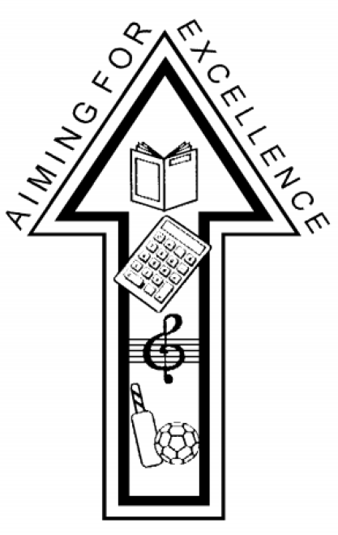

Roby Park Primary School
Remote Learning Policy

1. Statement of School Philosophy
Roby Park has always strived to support our parents/children in the best way possible to make learning purposeful and holistic. Our strategy for remote learning continues this.

2. Aims
This Remote Education Policy aims to:
- Plan a programme that's of equivalent length to the core teaching pupils would receive in school, ideally including daily contact with teachers
- Set assignments so that pupils have work each day in a number of different subjects, and monitor pupils' engagement with these assignments
- Teach a planned and sequenced curriculum so that knowledge and skills are built incrementally, with clarity about what's intended to be taught and practised in each subject
- Provide frequent explanations of new content, delivered by a teacher in your school or through curriculum resources and/or videos
- Gauge how well pupils are progressing through the curriculum, using questions and other suitable tasks, and set a clear expectation on how regularly teachers will check work
- Enable teachers to adjust the pace or difficulty of what's being taught in response to questions or assessments, including, where necessary, revising material or simplifying explanations to ensure pupils’ understanding
- Avoid an over-reliance on long-term projects or internet research activities
- Ensure consistency in the approach to remote learning for all pupils (Inc. SEND) who aren’t in school through use of quality Online and offline resources
- Include continuous delivery of the school curriculum, as well as support of Motivation, Health and Well-Being and Parent support
- Support effective communication between the school and families and support attendance

3. Who is this policy applicable to?
- A child (and their siblings if they are also attending Roby Park Primary) who is absent because they are awaiting test results and the household is required to self-isolate. The rest of their school bubble are attending school and being taught as normal.
- A child’s whole class bubble if it is not permitted to attend school because they, or another member of their class bubble, have tested positive for Covid-19.
- All pupils who are not attending school due to a partial closure.

Remote learning will be shared with families when they are absent due to Covid related reasons and not to all. Work will be uploaded daily, and available for pupils for 8.45am.
4. Content and Tools to Deliver This Remote Education Plan
Resources to deliver this Remote Education Plan include:
- Online tools for EYFS, KS1 & KS2 – Seesaw
- Phone calls home
- Printed learning packs (should a partial closure happen, places will be made available for pupils who will face technological difficulties or devices provided where possible)
- Physical materials such as story books and writing tools, if required
- Use of online platforms – Oak Tree Academy, Literacy Counts, White Rose, Oxford Reading Buddy, Language Angels, Spelling Shed, Class Charts etc
- Teacher Code of Conduct for Phone calls, Seesaw and Evidence Me

The detailed remote learning planning and resources to deliver this policy can be found here:
https://robyparkprimary.co.uk/our-school-3/covid-19/

5. Home and School Partnership

Roby Park Primary School is committed to working in close partnership with families and recognises each family is unique and because of this remote learning will look different for different families in order to suit their individual needs.
Where possible, it is beneficial for young people to maintain a regular and familiar routine. Roby Park Primary School would recommend that each ‘school day’ maintains structure.
We would encourage parents to support their children’s work, including finding an appropriate place to work and, to the best of their ability, support pupils with work encouraging them to work with good levels of concentration.

Every effort will be made by staff to ensure that work is set promptly, ready for every Wednesday morning. Should accessing work be an issue, parents should contact school promptly and alternative solutions may be available. These will be discussed on case-to-case basis. Please email outofhours@robyparkprimary.co.uk, should there be nobody in the office.

All children sign an ‘Acceptable Use Policy’ at school which includes e-safety rules and this applies when children are working on computers at home.
6. Roles and responsibilities

Teachers
To note: the suggested responsibilities below relate to where a whole class/bubble is isolating and would be reduced when it is fewer children isolating and the majority of the class are in school.

- Roby Park Primary School will provide a refresher training session and induction for new staff on how to use Seesaw and training will be given for Evidence Me.
- When providing remote learning, teachers must be available to upload daily feedback for their class, following the weekly work uploaded.
- Teachers will organise weekly phone calls for a catch up
- If they are unable to work for any reason during this time, for example due to sickness, they should report this using the normal absence procedure.

When providing remote learning, teachers are responsible for:
- Setting work:
  - Teachers will set work for the pupils in their classes.
  - The work set should follow the usual timetable for the class had they been in school, wherever possible
  - Work will be uploaded on a daily basis, ready for 8.45am every morning
  - Teachers in Reception to Y6 will be setting work on Seesaw
- Providing feedback on work:
  - Completed, submitted work will be checked on a daily basis and feedback given as appropriate to correct mistakes and acknowledge success.
- Keeping in touch with pupils who aren’t in school and their parents:
  - If there is a concern around the level of engagement of a pupil parents/carers should be contacted via phone to access whether school intervention can assist engagement.
  - All parent/carer emails should come through the school admin account outofhours@robyparkprimary.co.uk if there are any issues
  - Any complaints or concerns shared by parents or pupils should be reported to a member of SLT– for any safeguarding concerns, refer immediately to the Designated Safeguarding Lead (Mrs K Allen) or Deputy Designated Safeguarding Lead (Mrs K Lyon).
  - Daily posts on class Twitter pages will be used to engage families

Teaching Assistants
- Teaching assistants must be available during their usual working hours.
- If they are unable to work for any reason during this time, for example due to sickness, they should report this using the normal absence procedure.
- During the school day, teaching assistant must complete tasks as directed by a member of the SLT or their class teacher, if not working in school.

Senior Leaders
Alongside any teaching responsibilities, senior leaders are responsible for:
- Co-ordinating the remote learning approach across the school inc daily monitoring of engagement.
- Monitoring the effectiveness of remote learning – explain how they’ll do this, such as through regular meetings with teachers and subject leaders, reviewing work set or reaching out for feedback from pupils and parents
- Monitoring the security of remote learning systems, including data protection and safeguarding considerations

Designated safeguarding lead
- The DSL is responsible for managing and dealing with all safeguarding concerns. For further information, please see the Safeguarding and Child Protection Policy.

IT Technicians
IT technicians are responsible for:
- Fixing issues with systems used to set and collect work
- Helping staff with any technical issues they’re experiencing
- Reviewing the security of remote learning systems and flagging any data protection breaches to the data protection officer

The SENDCO
- Ensuring that pupils with EHCPs continue to have their needs met while learning remotely, and liaising with the Headteacher and other organisations to make any alternate arrangements for pupils with EHCPs and IHPs
- SENDCO will support 1:1 support staff engaging remotely with EHCP pupils
- Identifying the level of support needed by individual children on the SEN register

The SBM
- Ensuring value for money when arranging the procurement of equipment or technology.
- Ensuring that the school has adequate insurance to cover all remote working arrangements.

Pupils and parents
Staff can expect pupils learning remotely to:
- Complete work to the daily deadline set by teachers
- Seek help if they need it, from teachers
- Alert teachers if they’re not able to complete work

Staff can expect parents with children learning remotely to:
- Make the school aware if their child is sick or otherwise can’t complete work
- Seek help from the school if they need it by emailing outofhours@robyparkprimary.co.uk or adding a wellbeing comment on Class Charts
- Be respectful when making any complaints or concerns known to staff

Governing Body
The governing body is responsible for:
- Monitoring the school’s approach to providing remote learning to ensure education remains as high quality as possible
- Ensuring that staff are certain that remote learning systems are appropriately secure, for both data protection and safeguarding reasons

7. Links with other policies and development plans
This policy is linked to our:
- Positive Relationships & Behaviour Policy
- Child protection Policy
- Data Protection Policy and Privacy Notices
- Online Safety and Acceptable Use Policy
- Code of Conduct for Remote Learning

Appendix 1: Y1-6 Remote Learning Timetable

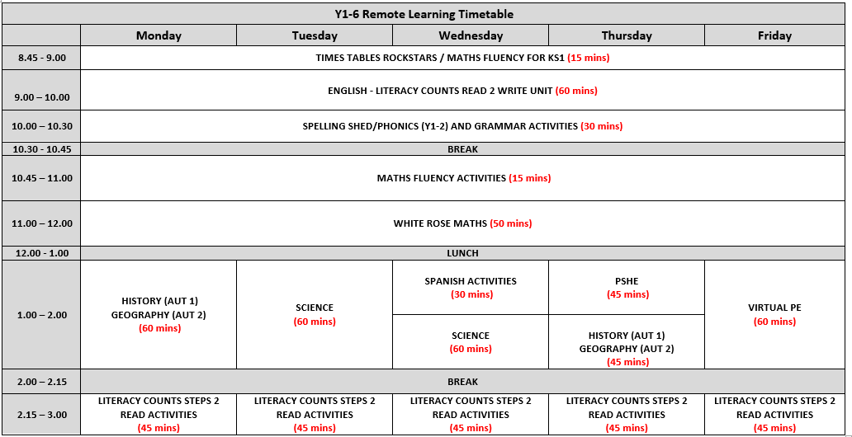

Appendix 2: Nursery Remote Learning Timetable

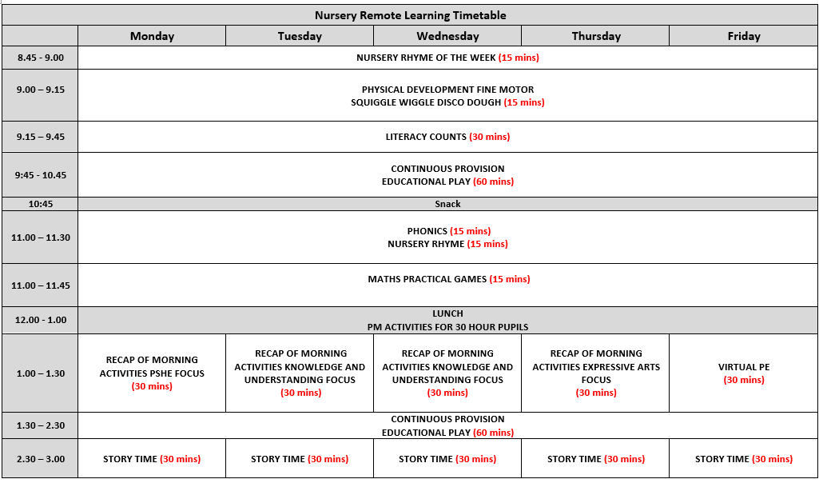

Appendix 3: Reception Remote Learning Timetable
