Roby Park Primary School
Covid19 Contingency Plan

Please note: this plan has been created in line with the advice regarding contingency planning in the DfE’s ‘Full opening guidance: schools’. There is currently no national guidance on how schools should operate during a local lockdown. Every local lockdown will be different depending on the circumstances of the area. If a local lockdown is implemented in our area, Roby Park Primary School will follow the specific guidance for our area. We will ensure this plan is updated in line with national government guidelines regarding the operation of schools during local lockdowns.

Contents:
- The aim of this plan
- On-site education
- Remote education
- Safeguarding
- Food provision
- Communication
- Monitoring and review

The aim of this plan
If our local area sees a spike in coronavirus (COVID-19) infection rates that is resulting in localised community spread, the appropriate authority will decide which measures to implement to help contain the spread – these measures could include the partial closure of schools in the area.
This document outlines how ROBY PARK will operate if a local lockdown is implemented and our school needs to close to all but the children of critical workers and vulnerable children (Tier 4 of CONTAIN). If a local lockdown is implemented in our area, the school will work closely with the local health protection team (HPT) and implement provisions as advised by the team.
This is a live document that will be reviewed by the Head Teacher in conjunction with other key stakeholders as and when the situation develops.

On-site provision
Pupils
The school will continue to offer on-site provisions for eligible pupils – eligible pupils are likely to be vulnerable pupils and children of critical workers. This list will be updated at the start of every term, via conversations with our parents. As before, the school will openly communicate with parents regarding eligibility.
The number of pupils who will be attending school, in any week, from these groups will be identified by asking parents to use the Parent App to secure the place once eligibility has been established. This number will be used to agree what staffing resource is required.
Vulnerable pupils and children of critical workers are permitted to travel into and out of the area for education – this includes parents taking their children to school.
In circumstances where a parent or carer of a child with a social worker does not want their child to attend the school, the school and the child’s social worker will explore the reasons for this directly with the parent or carer, and work together with them to support the child to attend. A specific plan, including a risk assessment, will be in place in order to support the family.
The Head Teacher will work will all relevant staff to decide appropriate pupil BUBBLES. We will work on the basic principle that class sizes are at least halved (with no more than 15 pupils per BUBBLE) and that at least one teacher will be allocated to each BUBBLE. Where there are teacher shortages, support staff may be asked to lead groups under the direction of a teacher.
We will also ensure that all appropriate support is in place for those pupils with SEND who are attending school, with interventions and specific pupil work continuing to take place during this time as much as possible.
Pupils will be kept in the same BUBBLE at all times each day, and different groups will not mix during the day, or on subsequent days. The same staff will be assigned to each BUBBLE and, as far as possible, staff will stay assigned to the same BUBBLE during the day and on subsequent days.
Staff
Critical workers, which includes school staff, are permitted to travel into and out of the lockdown areas to get to work, in order to maintain provision for pupils who will be attending on-site provision.
If shielding measures are reintroduced due to the local lockdown, affected members of staff will be supported to work from home or the appropriate leave or pay measures will be discussed.
Staff with roles that must be undertaken on site (e.g. teachers) will be asked to come into school to deliver provision, unless they are shielding or self-isolating. Staff members who are able to carry out their role from home will be supported to do so.
An audit of all staff will be updated to assess who is able to work on site and who will need to work from home due to their underlying health issues or those of the people they live with. The audit will be reviewed on a continuous basis to establish whether the circumstances of any staff member have changed.
If any staff member has concerns regarding working on the school site, they will discuss these concerns with their line manager.
Infection prevention and control
The school’s Infection Control Plan which id identified in the Risk Assessment will continue to be adhered to – this policy meets the requirements set out in the DfE’s system of controls.
Any member of the school community who displays symptoms of coronavirus will be encouraged to get a test. Tests can be booked online or ordered by telephone via NHS 119. Essential workers, including school staff, have priority access to testing.
If a pupil develops symptoms of coronavirus while on site, they will be taken to a designated Isolation Room (HT office) while they wait to be collected. If required, the pupil will be supervised while they await collection. If the supervising member of staff is unable to maintain social distancing, e.g. due to the pupil’s age or needs, they will wear PPE (this PPE is kept in a box within the ‘Isolation Room’). After the pupil has left the premises, any areas they were in will be thoroughly cleaned including any bathroom use (disabled bathroom). The pupil’s parents will be encouraged to get their child tested. The pupil will be required to self-isolate for at least 14 days – remote education will be arranged for them immediately.
If a staff member develops symptoms while on site, they will be directed to go home to self-isolate and to get a test. Internal cover arrangements will be put in place.
Any staff members or pupils who have been in close contact with a symptomatic individual do not need to self-isolate, unless they develop symptoms themselves or the individual subsequently tests positive.
If an individual tests positive, the school will contact the school’s link officer (Penny France) and local HPT and PHE. The individual’s close contacts at school will be sent home to self-isolate for 14 days and encouraged to get a test. If more individuals test positive, the school will follow advice from the local HPT, which may include requiring more people to self-isolate.
Transport
Pupils and staff that have to attend school will be encouraged to walk or cycle wherever possible and to avoid public transport. If pupils and staff need to use public transport, they will be reminded that those over the age of 11 are required to wear a face covering while travelling.

Remote education (for Tier 4 of the CONTAIN Framework)
If a local lockdown is implemented, the school will offer immediate access to remote education, via Seesaw, for pupils who are required to remain at home. If there is not a local lockdown, but a single class or BUBBLE needs to self-isolate, the school will immediately implement remote learning for that group.
All remote learning will be delivered in line with the School’s Blended Home Learning Policy.
For those families who have specified they do not have devices, which has been shared with staff, paper copies of home learning should be provided until the government provide laptops/tablets.

Teaching and learning
All pupils will have access to high-quality education when remote working.
The school will use a range of teaching methods. This includes:
- quizzes, online materials, videos, games, questioning and response
Teachers will ensure lessons are inclusive for all pupils and can be adapted and differentiated to account for the needs of disadvantaged pupils and pupils with SEND.
When teaching pupils who are working remotely, teachers will:
- Set assignments so that pupils have meaningful and ambitious work each day. Work will be set by Tuesday evening for the week ahead (Weds - Tues). Work will be uploaded in the library and assigned to specific pupils or whole class if in lockdown/bubble has closed.
- Deliver a planned, coherent and well-sequenced curriculum which allows skills to be built incrementally. Maths will be delivered through White Rose and English will be delivered via Literacy Counts remote Steps 2 Read and Read 2 Write units.
- Provide frequent, clear explanations of new content through high-quality curriculum resources, including the use of educational videos - White Rose, Oak Academy.
- Assess progress by using questions and other suitable tasks and be clear on how regularly work will be checked.
- Adjust the pace or difficulty of what is being taught in response to questions or assessments, including, where necessary, revising material or simplifying explanations to ensure pupils’ understanding.
- Plan a programme that is of equivalent length to the core teaching pupils would receive in school, and include contact from teachers where possible.
- During lockdown, TAs will be allocated to make daily contact with pupils.
All provisions for remote learning will be subject to the class group’s age, ability and/or any SEND.
In exceptional circumstances, the school may reduce its curriculum offering to enable pupils to cope with the workload – the Head Teacher will assess this need, keeping pupils’ best interests in mind, and will not take the decision lightly.
Teachers will continue to make use of formative assessments throughout the academic year, e.g. quizzes, Kahoot, White Rose, surveys
The school will utilise the support available through the DfE’s ‘Get help with technology during coronavirus (COVID-19)’ scheme. Under the scheme, the school can order laptops, tablets and 4G wireless routers to support the following groups of pupils if they do not have access to a digital device or the internet through other means:
- Pupils in Years 3 to 11
- Clinically extremely vulnerable children across all year groups who are shielding or self-isolating in line with government and/or clinical advice
- Children in all year groups who are unable to access remote education whilst attending school on a hospital site
Before distributing devices, the school will ensure:
- The devices are set up to access remote education.
- Appropriate safeguarding controls and support are in place to help pupils and their families use the devices safely.
Once devices are ready for collection, the school will either arrange for them to be collected by families from school or delivered to pupils’ homes, ensuring infection control measures are adhered to as part of this process. If ROBY PARK have any devices available which could be used at home, for vulnerable pupils, an agreement will be signed by parents and the school before these devices are loaned.
If further devices are made available through the DfE laptops and tablets for disadvantaged children to access remote education if local COVID-19 restrictions are required, these will be issued in line with the guidance to:
- Pupils in years 3-6;
- Clinically extremely vulnerable children across all year groups who are shielding on official advice;
- Children in all year groups unable to access remote education whilst attending school on a hospital site
Families were canvassed at the beginning of Autumn term and the families who said they do not have access to a laptop or tablet have been shared with all staff. All of the pupils above need to be provided with paper copies of home learning until devices are available.
Our approach to remote learning (please see Appendix A detail)
In the event of a full closure, pupils will be sent home with:
- Logins which have already been distributed - Seesaw, Class Charts, ORB, TTRs, Number Bots, Language Angels, Monster Phonics
- A timetable of learning to help to organise the day
(Critical Worker and Vulnerable Pupils remaining would have their information sent to their new BUBBLE).
The Senior Leadership Group will:
- Ensure those families entitled to Free School Meals will be provided with food or vouchers
- Ensure the home learning tasks set are to a high standard in line with year group expectations
- Monitor the phone logs and CPOMs to ensure families are called regularly and any issues are followed up
- Monitor the engagement of pupils learning
- Communicate regularly with families through Sims ParentApp, SeeSaw, website, social media, Class Charts, emails and phone calls
- Meet regularly with staff to address any positives and next steps (this could be in person or through virtual media)
- Responds to parents’ queries and concerns via the outofhours@robyparkprimary.co.uk email address which is active for lockdowns only
- Ensure the day to day running of ‘remote’ education and the learning and safety of those on site (Key Worker and Vulnerable Pupils)
Class Teachers will:
- Zoom sessions 3x a week - Check in/Check up/Check out (Mon, Weds, Fri) - password protected links sent via email
- Follow their usual planning for all subjects
- Follow their usual timetable of learning each day, through a virtual platform, where possible
- Provide opportunities to ensure children understand their learning tasks, with clear, high quality daily learning targets through SeeSaw
- Feedback to pupils on their uploaded learning
- Provide additional support for children/parents through explanations via video/audio messages on Seesaw
- Share a story time video x 3 weekly using Class Novels from our reading spine
- TAs will speak with all pupils on at least a weekly basis via phone call.
- Teachers will hold a weekly PSHE time for classes via Zoom - invites, with passwords, sent via Sims ParentApp
- Monitor the daily engagement of pupils and class teachers to contact the families of those not engaging to offer support
- Log any safeguarding concerns by immediately via CPOMs and telephoning the DSL or Deputy DSL
SENDCo will:
- Call identified families regularly to offer support and check on children’s well-being
- Liaise with outside agencies, including the Police as appropriate to need
- Take part in remote meetings as appropriate to need
- Conduct home visits to families unable to contact or who are causing concern, in line with control measures and government guidance
- Follow up any concerns promptly
Pupils/Parents will:
- Watch all of the learning videos, taking a full and active part in them
- Complete the learning set by their teacher each day and upload their learning as requested by the teacher
- Watch their story time
- Talk with their friends x 3 times weekly through safe – check in, check-up and check out (Mon, Weds, Friday)
- Use on line resources such as TTRS, ORB, Monster Phonics etc

Parents will:
- Be given clear guidance on the use of SeeSaw and Class Charts
- Set a clear routine with each child using the timetable and the daily learning set
- Read all communications that is sent out to ensure they are fully aware and up to date with news for our school - Seesaw and Sims ParentApp
- Support their children to complete all of the learning set
- Liaise with school staff and seek support on behalf of their child when needed, with class teacher via Seesaw or Class Charts (wellbeing only)
- Ensure courtesy and politeness to any member of staff within any communication
- Provide access to the learning offered for their children
- Support their children by uploading learning to Seesaw
- Liaise with school staff to communicate how well their child(ren) attempt the work set
Critical Worker & Vulnerable Children:
If it is appropriate to be open to Key Worker and Vulnerable Pupils, they will be placed into BUBBLES with 2 consistent members of staff.
They will complete all remote learning set by their class teachers on iPads or laptops while in school.
Class Closures/Partial Closure
If a class, a BUBBLE, a number of classes, or a number of BUBBLES have to close due to a positive COVID-19 test, then they will follow the procedure described for full closure.
Critical Workers and Vulnerable Pupils would not be learning at ROBY PARK if they are part of any closed group due to a positive COVID-19 test.
If the class teacher is ill and unable to work, another member of staff will take over their role and ensure the remote learning is set up and running as described.
Returning to school
The Head Teacher will work with the LA to ensure pupils only return to school when it is safe for them to do so. Prior to the return of more pupils and staff, all relevant risk assessments will be reviewed.
After a period of self-isolation, or the lessening of local lockdown rules, the Head Teacher will inform parents when their child will return to school.
The Head Teacher will listen to all concerns that parents may have about their child returning to school and will advise them of the measures in place to ensure the safety of their child.

Safeguarding
Ensuring safeguarding arrangements remain effective while the school is partially closed is a key priority.
Our Child Protection Policy, with addendums, was updated during the national lockdown to include provisions for keeping pupils safe during the coronavirus pandemic – we will continue to follow these procedures for pupils who remain at home, where appropriate, until all pupils are able to return to school.
We will continue to ensure that:
- The best interests of pupils always come first.
- If anyone in the school has a safeguarding concern about a pupil, they act immediately and record on CPOMs
- A DSL or deputy DSL is always available.
- Unsuitable individuals are not permitted to work with pupils or come into contact with pupils whilst on site.
- Pupils who remain at home are protected when they are online.

Food provision
We will ensure measures are in place so that meals can be prepared and served safely for pupils who remain on site.
The school catering team will work with the Local Authority to ensure we can continue offering FSM to pupils and families who are eligible. Further details regarding this provision will be emailed to all parents in the event of a local lockdown.

Communication
The school will communicate its plan for a local lockdown with parents, including whether it will remain open to vulnerable pupils and children of critical workers, or if remote working will be applicable for all.
All relevant stakeholders will be kept up-to-date with the circumstances of the local lockdown and how it affects the school as they develop.
If any member of the school community wishes to discuss any concerns relating to the school’s provision during this period, they should contact the following as appropriate:
- Staff – HT or AHT
- Pupils – their class teacher
- Parents – HT or AHT
Monitoring and review
This plan will be reviewed continually in line with guidance from the government and Public Health England (PHE).
Any changes to the plan will be communicated to all relevant stakeholders.

Signed by:
Head Teacher Date: 28.9.2020
Chair of governors Date:

Appendix A

Individual self-isolating or shielding  Group of children | EYFS BUBBLE |  |  | Year 1 - 6
 | - Remote education in place to commence immediately  - Upload activities for the week, on to Seesaw, by Tuesday evening. Work will cover Weds-Weds.  - Time table for the week to be provided.  - Resources for the week, dialogue and discussion between teacher and home through Seesaw to support and guide child.  - Recognition to be given in line with school policy – celebration assembly every Friday.  - Feedback to be given through Seesaw to encourage and extend children’s learning.  - Printed resources available for pupils who are self-isolating, with 24 hours’ notice for those who have informed us they do not have devices for remote learning. |  |  | - Remote education in place to commence immediately  - Upload activities for the week, on to Seesaw, by Tuesday evening. Work will cover Weds-Weds.  - Time table for the week to be provided.  - Resources for the week, dialogue and discussion between teacher and home through SeeSaw to support and guide child.  - Recognition to be given in line with school policy e.g. WAGOLL, Personal Best, celebration assembly, postcard home  - Feedback to be given through SeeSaw to encourage and extend children’s learning.  - Printed resources available for pupils who are self-isolating, with 24 hours’ notice for those who have informed us they do not have devices for remote learning.
PROVISION:
- Oak National Academy resources that align with current Science and Humanities topics
- White Rose Premium Maths video lessons and resources.
- TTRS.
- Numbots
- Oxford Reading Buddy
- Class Charts
- Literacy Counts Read 2 Write – remote online learning resources
- Literacy Counts Steps 2 Read – remote online learning resources
- Monster Phonics
LOCAL LOCKDOWN FOR ENTIRE SCHOOL – CONTINGENCY PLANNING
 |  | EYFS | Y1 & Y2 |  | Y3 & Y4 | Y5 & Y6
Curriculum sequence is aligned to published online resources and teaching videos |  | - Maths and phonics aligned to White Rose/Power Maths  - Project work will use Oak National Academy and align to planned curriculum as appropriate | - Maths, phonics and SPAG aligned to White Rose and Literacy Counts  - Foundation subject slides uploaded will be aligned to planned curriculum as appropriate |  | - Maths, phonics and SPAG aligned to White Rose and Literacy Counts  - Foundation subject slides uploaded will be aligned to planned curriculum as appropriate | - Maths, phonics and SPAG aligned to White Rose and Literacy Counts  - Foundation subject slides uploaded will be aligned to planned curriculum as appropriate
High quality education resources, including online teaching from all staff |  | - Up to 30 minutes per day Maths and phonics – weblinks to Letters and Sounds daily lessons supplemented with Monster Phonics  - Remainder of curriculum to be set along in school expectations using remote resources. | - Up to 40 minutes per day Maths, phonics and SPAG – using Apps  - Remainder of curriculum to be set along in school expectations using remote resources. |  | - 1 hour plus per day maths and SPAG – using Apps  - Remainder of curriculum to be set along in school expectations using remote resources. | - 1 hour plus per day maths and SPAG – using Apps  - Remainder of curriculum to be set along in school expectations using remote resources.
Online tools and resources to communicate |  | - All children/ parents have access through Seesaw and Evidence Me to communicate with their teacher and TA  - Zoom sessions with parents if needed to support learning | - All children/ parents have access through SeeSaw to communicate with their teacher and TA  - Zoom sessions with parents if needed to support learning |  | - All children/ parents have access through SeeSaw to communicate with their teacher and TA  - Zoom sessions with parents if needed to support learning | - All children/ parents have access through SeeSaw to communicate with their teacher and TA  - Zoom sessions with parents if needed to support learning
Online policy for Remote Teaching and Learning |  | - In place and to be agreed by governors | - In place and to be agreed by governors |  | - In place and to be agreed by governors | - In place and to be agreed by governors
Interaction – high quality, clear daily learning targets (DLT’s) frequent, clear explanations of new content, delivered by teacher in school or high quality curriculum resources or videos |  | - Class teacher  - TAs – weekly calls  - Tasks set for the day, following planned curriculum, including planned clips  - TAs - Recorded stories  - Daily phonics session to be included within direct teaching  - Weekly x 3 Zoom check in, check-up and check out | - Class teacher  - Tasks set for the day, following planned curriculum, including planned clips  - Recorded stories  - Daily phonics session to be included within direct teaching  - Weekly Zoom check in check-up and check out |  | - Class teacher  - Tasks set for the day, following planned curriculum, including planned clips  - Recorded stories  - Focus on key skills  - Weekly Zoom check in check-up and check out | - Class teacher  - Tasks set for the day, following planned curriculum, including planned clips  - Recorded stories  - Focus on key skills  - Weekly Zoom check in check-up and check out
Assessment |  | - Through daily phonics  - Work uploaded onto Seesaw/Evidence Me  - Gauge progress through the curriculum, using question and other suitable tasks  - Teachers will check work at least once per day | - Through daily phonics  - Work uploaded onto SeeSaw  - Through dialogue with parents  - Gauge progress through the curriculum, using question and other suitable tasks  - Teachers will check work once per day |  | - Work uploaded onto SeeSaw  - Through dialogue with parents  - Gauge progress through the curriculum, using question and other suitable tasks  - Teachers will check work once per day | - Work uploaded onto SeeSaw  - Through dialogue with parents  - Gauge progress through the curriculum, using question and other suitable tasks  - Teachers will check work once per day
Feedback – through questioning, dialogue with parents, photos and physical evidence of work |  | - Gauge how well children are progressing through the curriculum, child-engaged assessment model - using questioning, dialogue (parents and children), feedback on work shared | - Gauge how well children are progressing through the curriculum, using ROBY PARK child-engaged assessment approaches - questioning, dialogue (parents and children), feedback on work shared and physical workbooks returned to school |  | - Gauge how well children are progressing through the curriculum, using ROBY PARK child-engaged assessment approaches - questioning, dialogue (parents and children), feedback on work shared and physical workbooks returned to school | - Gauge how well children are progressing through the curriculum, using ROBY PARK child-engaged assessment approaches questioning, dialogue (parents and children), feedback on work shared and physical workbooks returned to school
Printed resources for those who do not have suitable online access |  | - Printed resources available for those who do not have access to technology at home
Additional support for pupils with SEND |  | - Depends upon individual needs  - Zoom sessions for pupils who need additional support with KL.  - TA targeted support for 1:1 pupils and vulnerable families
Daily lessons set via SeeSaw, with selected timetable for the day |  | - Uploaded onto Seesaw, by Tuesday evening so it is there for Weds mornings. The work will be uploaded for the week ahead (Weds-Weds)
Objectives for our curriculum |  | - If a child or a group of children are away and do not access the learning then our task in school is to ensure that we do all we can to support engagement.  - Follow our EYFS curriculum so knowledge and skills are built incrementally, with a good level of clarity about what is intended to be taught and practised in each area of learning | - If a child or a group of children are away and do not access the learning, then our task in school is to ensure that we do all we can to support engagement. Follow our planned curriculum so knowledge and skills are built incrementally, with a good level of clarity about what is intended to be taught and practised in each subject
Curriculum coverage |  | - Weekly timetable uploaded onto Seesaw, ensuring all elements of curriculum.  - Ensure that programme is of similar length to the core teaching pupils would receive in school
Additional Communication |  | - Telephone calls to pupils/ parents (especially those not engaging) by class teachers as per lockdown protocol  - SENDCo will continue to make weekly contact with most vulnerable families  - TAs make weekly contact calls

Appendix B: Y1-6 Remote Learning Timetable
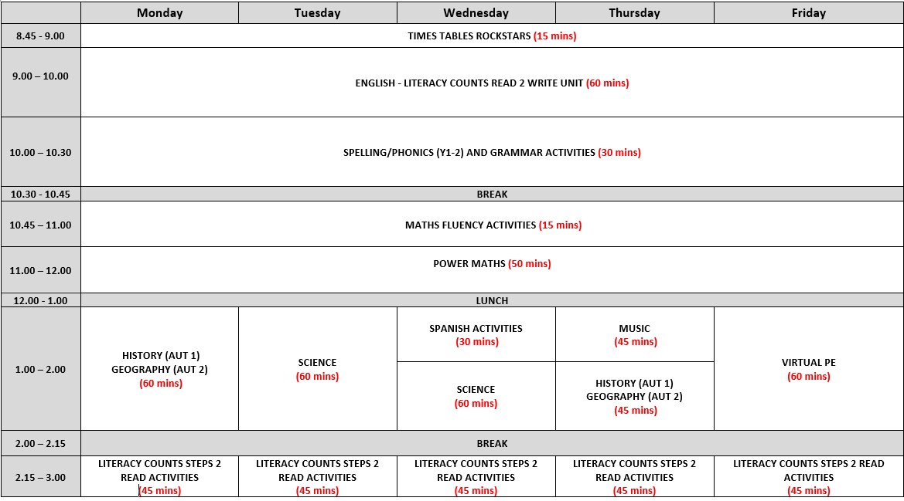

Appendix C: Nursery Remote Learning Timetable
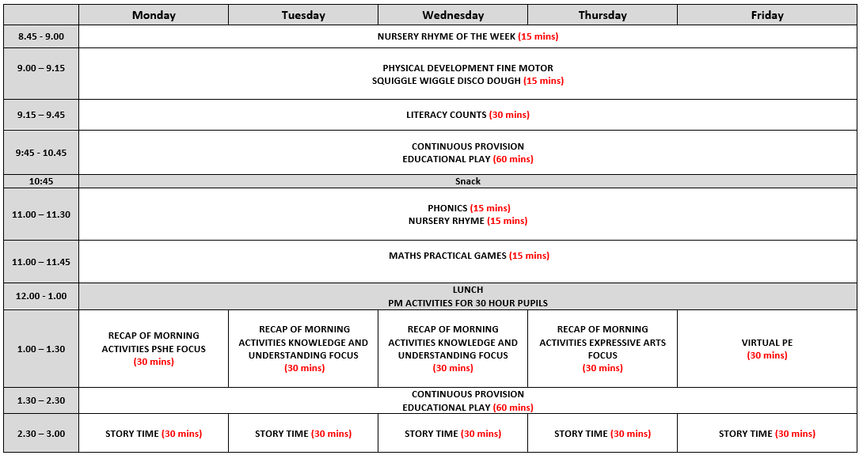

Appendix D: Reception Remote Learning Timetable
