Roby Park Primary School

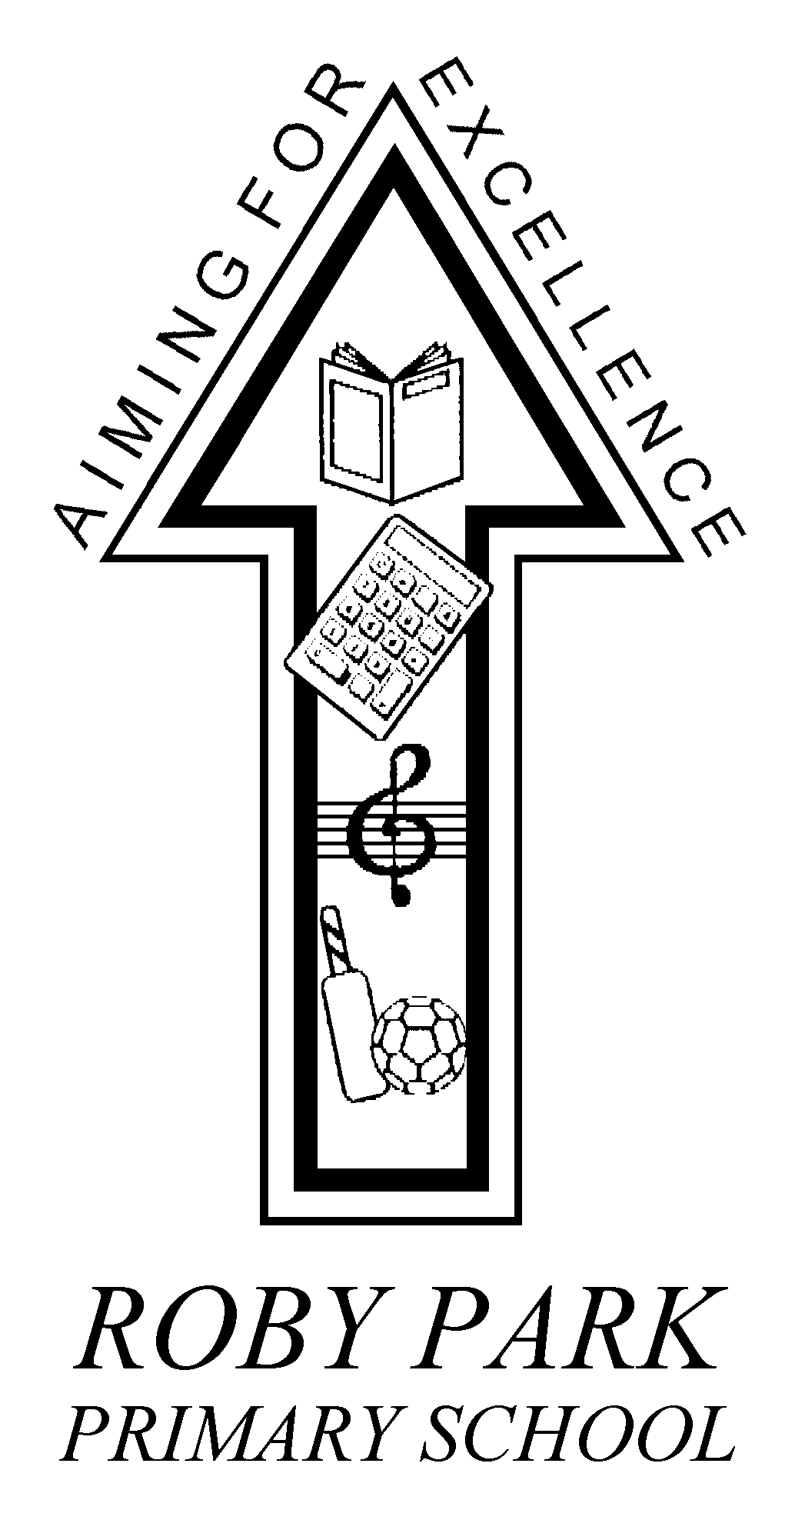Easton Road

Huyton

Knowsley

L36 4NY

Tel: 0151 477 8340

Website: www.robyparkprimary.co.uk

E-mail: robypark@knowsley.gov.uk

Headteacher: Mrs K Allen

Date: 6th May

Dear Parent/Carer,

IMPORTANT INFORMATION REGARDING THE FREE SCHOOL MEAL VOUCHER SCHEME

As a group of schools forming the Central Collaborative we are writing to you with an update about the voucher system which is currently used to support you during this time of difficulty. We are delighted that the service provided by WONDE has been so effective and that very few problems have been reported. Knowsley Council have taken the decision to carry on with WONDE to deliver vouchers for the time being which is good for both schools and families as we can be sure our children are being looked after. There is also another national provider of vouchers who Knowsley may look to move to in the future if necessary, but only when we can be sure they can deliver an efficient service.

At the beginning of this unprecedented situation with COVID-19, Knowsley took the decision to provide meals vouchers for both means tested free schools meals eligible children and also to all other children in year groups Reception, Year 1 and Year 2, as part of the universal free schools meal provision. This decision was welcomed and appreciated in these challenging times.

As we now move further into the current school closure period, Knowsley Council has had to reconsider its approach so it is more in line with other authorities nationally. Unfortunately, it is not sustainable for the Council to continue to fund vouchers for all. Knowsley have therefore decided that this funding will not carry on and with immediate effect, vouchers will now only be provided to those families who are eligible due to low income and means testing. We appreciate that this will be disappointing news to many but we are sure you will also understand that the Council must also keep within spending limits. More information can be found in the article in the Knowsley News: https://www.knowsleynews.co.uk/free-school-meals-eligibility-system/

Are you eligible for means tested Free School Meals?
The Council have asked schools to encourage parents and carers to check if they are eligible for a free school meal for their child / children, given that many parents’ and carers’ work situations may have changed due to COVID-19. Some parents/carers of infant children may not have applied previously as they are automatically entitled to free school meals under the Universal offer. We want to be sure that we are issuing as many vouchers as possible over the remaining period of the lockdown – maximising this uptake will help to ensure that no pupils who are eligible for a free school meal go without one.

The application form for Free School Meals is attached to this letter, if you are a Knowsley resident. If you have any issues or need advice re. free school meals please contact the Knowsley Council Benefits Section on 0151 443 4042. Completed forms can be returned to the One Stop Shop or emailed to benefits@knowsley.gov.uk. If you are a Liverpool resident then the form can be accessed here https://liverpool.gov.uk/benefits/free-school-meals/.

Please click here to check eligibility: https://www.knowsley.gov.uk/residents/education-and-schools/school-meals-and-menus.aspx

If you are a Liverpool resident, you can click on the link below where you can complete an online application: https://liverpool.gov.uk/benefits/free-school-meals

Please also remember that if you are aware of any family in need of support, they can contact the Knowsley Support and Volunteer freephone line on 0800 073 0043. Staff are available to take their call 24/7 and will help people to access support during these challenging times.

As a group of schools we would like to take this opportunity to thank you all for the support you have given us during these difficult times. It has been so lovely to receive feedback from parents and carers, and even more so from your children. We will, of course, continue to do everything we can to support all our school communities.

Thank you for your continued support.

Warmest regards
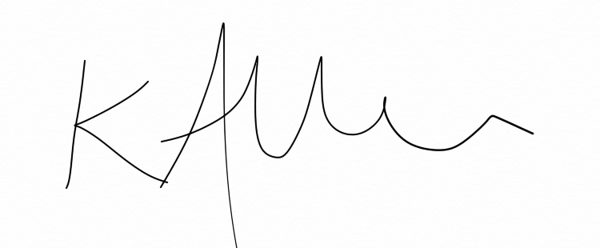

Mrs Kat Allen

Headteacher

Roby Park St Anne’s St Aloysius
St Margaret Mary’s Juniors St Aidan’s St Brigid’s
St Margaret Mary’s Infants Hope Huyton with Roby
Stockbridge Village Primary St Columba’s Willow Tree
Lord Derby Academy Sylvester St Joseph’s
Malvern Park View Alt Bridge
Blacklow Brow Knowsley Lane
Central St Albert’s

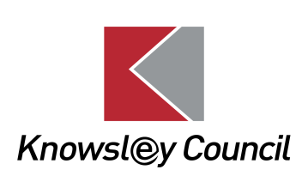APPLICATION FOR FREE SCHOOL MEALS
You do not need to complete this form if you are getting or wish to claim Housing Benefit and/or Council Tax Reduction, you will be notified of your entitlement automatically.

If you are not receiving Housing Benefit/Council Tax Reduction please enclose your Child Benefit award letter showing your current address and the names of the children you wish to claim free school meals for.

You can claim Free School Meals if you receive one of the following benefits:

- Income Support
- Income Based Jobseekers Allowance
- Income-Related Employment Support Allowance
- Child Tax Credit and income of less than £16,190 (but not if you are in work and receiving Working Tax Credit)
- The Guarantee element of State Pension Credit
- Support under part VI of the Immigration & Asylum Act 1999
- Universal Credit, provided they have an annual net earned income not exceeding £7,400 (£616.67 per month)

If you are a child and receive Income Support, Income based Job Seekers Allowance, Income Related Employment and Support Allowance or Universal Credit for yourself you can apply for your own free school meals. Please complete this form and put your own details in all the sections.

THE PERSON RECEIVING THE QUALIFYING BENEFITS MUST COMPLETE THIS FORM:
Your details:
Title Surname First Name(s) Date of Birth National Insurance Number

Your partner’s details:
Title Surname First Name(s) Date of Birth National Insurance Number

Current Address Give details of any changes of surname or address
……………………………………………………………………………………..
………………………………………………………………………………………………………………………………………………………………………
Postcode………………………………………………………
Day time telephone number ……………………………….
Mobile number……………………………………………….
Email address ……………………………………………….

PLEASE ENTER BELOW DETAILS OF SCHOOL AGE CHILDREN WHO LIVE WITH YOU

Surname | First Name | Date of birth | Relationship to you or your partner | School name | School Year (e.g. year 7)

PARENT/CARER DECLARATION:
Please read the declaration below. We will not be able to process your application without a signed declaration.
- I confirm that the information given on this form is complete and correct.
- I will inform you immediately if any of the details on the form change.
- I will inform you immediately if my financial circumstances change.
- I agree that you will use the information I have provided to process my claim for free school meals and will contact other sources as allowed by law to verify my initial, and ongoing, entitlement. I understand that the results of any free school meals eligibility check may also be used to assess my entitlement to receive school transport if appropriate.
- I understand that I will have to pay for the cost of the meals taken if I do not tell you about any change of circumstances and my child/ren receive free school meals that they were not entitled to.

General Data Protection Regulations

The information that you give on this form will be used for the purpose of processing your application for free school meals. The Local Authority is under a duty to protect the public funds it handles and may use the information you have provided to prevent and detect fraud. We also share this information, for the same purpose, with other government departments that handle public funds.

Signature: ………………………………………………… Date: ………………………………

When you have completed the form, sign it and bring it in with proof to one of our One Stop Shops or post the form to:

Knowsley MBC, Benefits Section, Municipal Buildings, Archway Road, Huyton L36 9YU.

You can contact us by telephone on 0151 443 4042 if you need any advice.
You can also get this information in other formats. Please phone us on 0151 443 4031, or email customerservices@knowsley.gov.uk

