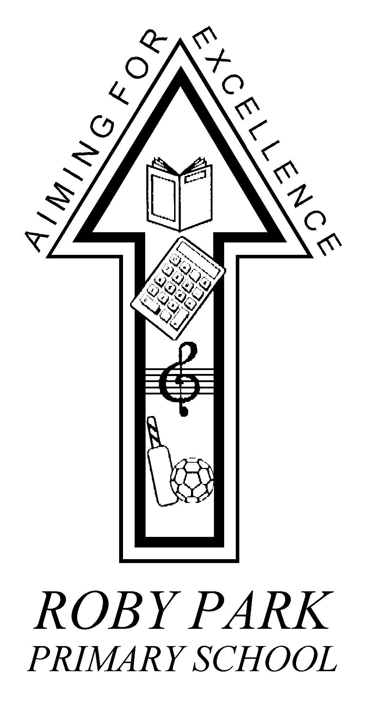

Roby Park Primary School

Easton Road

Huyton

Knowsley

L36 4NY

Tel: 0151 477 8340

Website: www.robyparkprimary.co.uk

E-mail: robypark@knowsley.gov.uk

Headteacher: Mrs K Allen

17th March 2020

Dear Parents/Carers,

This letter aims to update you on our preparations within school in response to the spread of Coronavirus (Covid 19) 1 p.m. on 17.3.2020. Updates from the Department for Education, Knowsley Council and Public Health England have been used as a basis for our planning. We recognise that people will understandably be concerned at this time, therefore we just want to reassure you that the school is monitoring the situation closely, is in regular contact with relevant authorities and has comprehensive plans in place. This will be a worrying time for you all and would like to assure you that comprehensive plans are in place in school.

Currently, there are no school closures in Knowsley. The Local Authority will continue to advise schools of actions in line with Government recommendations.

Day to Day Response
We are encouraging all of our staff and children to follow Public Health guidance and keep high levels of personal hygiene; this includes making sure that we are directing children and staff to wash their hands:
  - before leaving home
  - on arrival at school
  - after using the toilet
  - after breaks and sporting activities
  - before food preparation
  - before eating any food, including snacks
  - before leaving school
Children can bring hand sanitiser to school with them to use throughout the day if they wish but please be assured that we have plenty of hand wash available in school for children to use.

Our standard cleaning processes will continue but are also taking extra precautions within our cleaning arrangements and making sure that frequent contact points such as door handles are cleaned more regularly. Our Cleaning Provider has assured us that plans are in place to provide an enhanced or deep clean quickly as and when required.

We have talked to the children about the virus and how it is spread so that they can make sensible choices and follow the Public Health Guidance and ensure they carry tissues to ‘Catch it, Kill it, Bin it.’

Signs and Symptoms of COVID-19
The most common symptoms of coronavirus (COVID-19) are:
- new continuous cough and/or
- high temperature

For most people, coronavirus (COVID-19) will be a mild infection.
Generally, these infections can cause more severe symptoms in people with weakened immune systems, older people, and those with long-term conditions like diabetes, cancer and chronic lung disease. There is no evidence that children are more affected than other age groups – and it is important to remember that very few cases have been reported in children so far.
If you or a family member present with these symptoms the advice of health professionals is to self-isolate for 14 days. Guidance on https://www.gov.uk/government/publications/covid-19-stay-at-home-guidance/stay-at-home-guidance-for-people-with-confirmed-or-possible-coronavirus-covid-19-infection

After 14 days, if anyone is still unwell, then seek medical advice NHS 111 online. If you have no internet access call NHS 111. If symptoms worsen during your self-isolation, seek prompt medical advice.

If children feel better after 14 days and no longer have a temperature, they can return to school. The guidance does say that a cough may persist for several weeks in some people, despite the Coronavirus infection having cleared.

Reporting Absence:
Continue to follow the school attendance policy and report any illnesses by 8.45am on the first day of absence. If your child is displaying symptoms of a high temperature and/or continuous new cough, please report to the office on 0151 477 8340 and they will be recorded as having authorised absence. If children are self-isolating due to a member of the household displaying symptoms, this will be recorded as a Y code for authorised exceptional circumstances. We would like to reassure all families that there is no concern regarding fixed term penalty notices during these difficult times.

Communication
The school website will communicate regular updates on the homepage. Our website can be found at https://robyparkprimary.co.uk/

More instant updates will be found on our school Twitter page @RobyParkSchool and our Facebook page @RobyParkPrimarySchool. It is advisable that you follow these accounts for up to date information. We will be sharing information from the government and Public Health England as and when we get it. All information you need in relation to changes at school will be posted on official channels and we ask that you do not rely on other sources such as non school related social media to inform your decision making

If you need to contact school out of hours, please leave a voicemail on our school telephone (0151 477 8340).

A temporary email address has been set up for parents to contact myself, and Ms Lyon, outside of school hours in an emergency. This will be checked regularly. The email address is outofhours@robyparkprimary.co.uk.

Planning in Place:
The Council is working to ensure that any local response to COVID-19 is co-ordinated and services to schools are included in this planning. Contingency plans are in place for Council services to schools and we are receiving regular updates in relation to this.

An important part of our preparations are making sure that we have contingency plans for a variety of scenarios, including a temporary closure if instructed to do so by Public Health England.

We have made the decision to cancel any non-essential visitors to school and staff have been instructed to not attend any non-essential meetings offsite.

Following yesterday’s advice, from the government, Roby Park is having to implement social distancing and limiting the contact of groups of people in order to protect staff with underlying health conditions. This has resulted in us having to have a partial closure of school.

As of tomorrow, Years 1, 2, 3, 4, 5 & 6 will be fully open and children should attend as normal. Children will be on full timetables, accessing the full curriculum as normal.

However from tomorrow, Wednesday 18th March, Nursery and Reception will face a full closure until further notice.

We would like to reassure you that we have restructured staffing so that we can continue to provide high quality provision for your children whilst safeguarding staff, pupils and families.

There are clear management structures and systems in place for school to run effectively and safely with our very capable and experienced team. Mrs McCormick will be in charge on site whilst myself and Mrs Lyon will be remotely working and obtainable during all working hours.

For Nursery and Reception, workbooks and resources will be uploaded, to the school website this evening, to ensure children have sufficient provision. Resource lists of additional websites and learning materials, which can be accessed for free, will also be uploaded for families.

Currently, we have planned for 2 further separate scenarios:
- Instruction from Government to close for a specified period of time
In this instance, children will be provided with blank exercise books and age related workbooks will be made available on their class page on the school website https://robyparkprimary.co.uk/

Workbooks and resources will be updated regularly, on the school website, to ensure your children have sufficient provision. Resource lists of additional websites and learning materials, which can be accessed for free, will also be uploaded for families.

Families need to regularly check the school website and social media accounts for updates.

- Staff absence levels cause the need for closure
See above regarding provision in place for children.

Forthcoming Events at School:
We have reviewed all trips, extra-curricular clubs, events, fixtures and visits and have postponed them for the foreseeable future. We will update as and when decisions are made.

We hope that implementing such plans will not be necessary but we will always make decisions with the needs, health and welfare of children first.

Thank you for your continued support and your understanding in this matter.

Yours faithfully
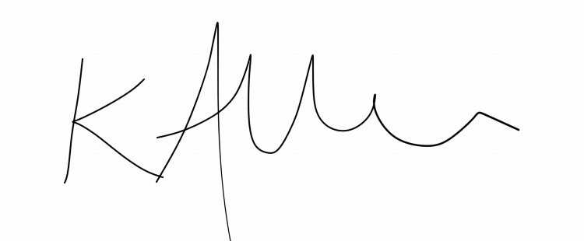
Mrs Allen
Headteacher

