Dear Parents/Guardians,
BikeRight! will soon be coming to your child’s school to run a Bikeability course which your child has the opportunity to take part in. Listed below are details of the course and what your child will need to be able to take part.
Dates of the course: Monday 24th February
Consent form (attached) must be returned to the school by: Friday 14th January
What is Bikeability?
Bikeability is the new Cycling Proficiency for the 21st century. It’s designed to give the next generation the skills and confidence to ride their bikes on today's roads. We will teach children to ride a bike to National Standards and introduce them to cycling as an everyday, fun, healthy activity and an alternative mode of transport.
How much will it cost?
Nothing! The course is funded by your Local Authority and Department for Transport grants.
What will my child need?
- A signed consent form – please use the form below.
- A Helmet
- A bike which is road-worthy. Please follow the simple guide below to check whether your child’s bike is suitable.
- Appropriate clothing. It is important, especially during the cooler months, that children wear gloves and warm, dry clothing as they will be outside for 2 hours.
- The ability to ride a bike unaided.

Bike Check
Handlebars and saddle: Please check these are adjusted to the correct height and are not loose.
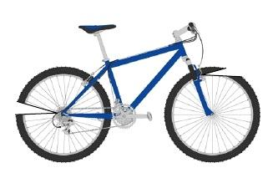
Tyres: Please check these are fully inflated.
Brakes: Please check that both front and back brakes work and can be used by your child.
Gears: Please check that these function properly.
Pedals and cranks: Make sure they are not loose or broken.
Please note that children cannot take part if their bikes are considered unsafe.

How is the Training delivered?
BikeRight!’s qualified instructors, who all hold current Enhanced Disclosure and Barring Service (DBS) certificates, will deliver two full days of training consisting of 4 sessions, each lasting 2 hours. Children will not automatically take part in every session.
Where will the course take place?
The course will take place in the school playground and on local roads near to the school. We will carry out a risk assessment of the training areas before the start of the course. A copy of the risk assessment will be available at the school.

