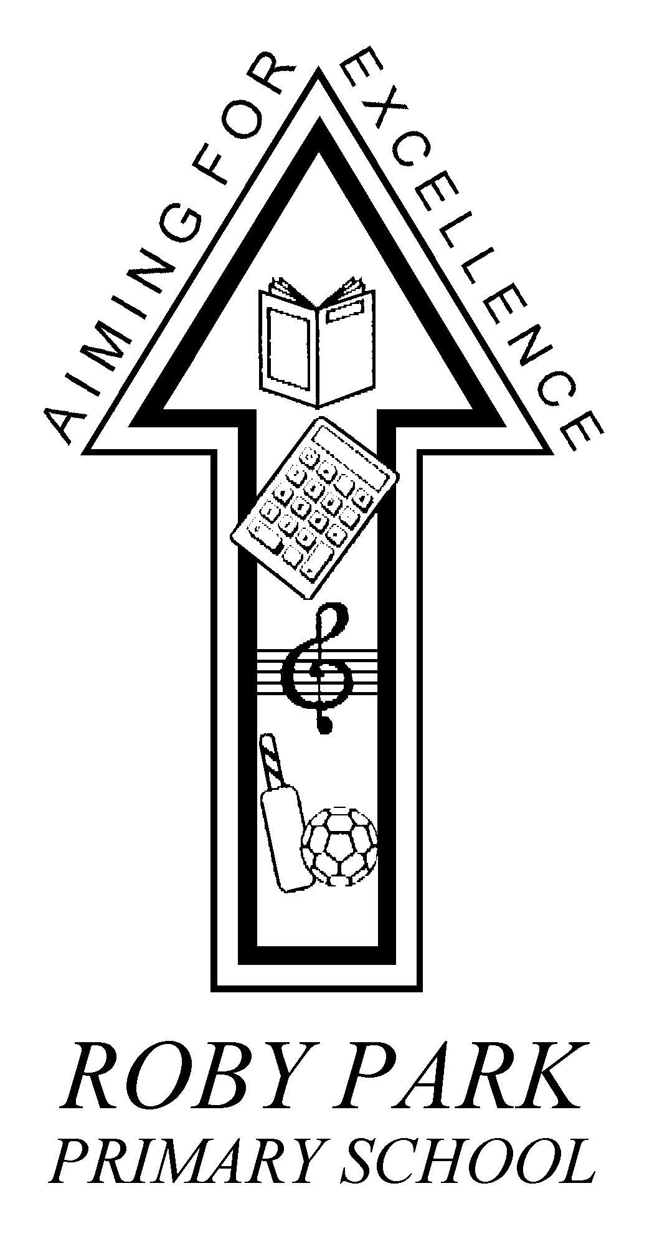

Roby Park Primary School

Easton Road

Huyton

Knowsley

L36 4NY

Tel: 0151 477 8340

Website: www.robyparkprimary.co.uk

E-mail: robypark@knowsley.gov.uk

Headteacher: Mrs K Allen

21st October 2019

Dear Parents/Carers,

Snack Shack-Years 1-6

Just a polite reminder that snack shack is an initiative run by volunteers who are selling weekly tokens from 8.30am-8.45am every Monday morning. School starts at 8.45am so children need to be inside and our volunteers have other commitments which they need to leave promptly for.

As stated previously, tokens will not be sold after this time so please leave for school
5 minutes early. If you cannot leave 5 minutes early, please provide your child with a healthy snack and drink. KS1 pupils still receive milk and fruit. This is not statutory but additional. There is no pressure to buy tokens but if you would like to buy them in advance on the Monday morning for a few weeks or the half term then please do so.

Abuse towards staff and volunteers will not be tolerated. It is unacceptable that anybody starts their day in such a way.

Yours faithfully,

Mrs Allen
Headteacher

