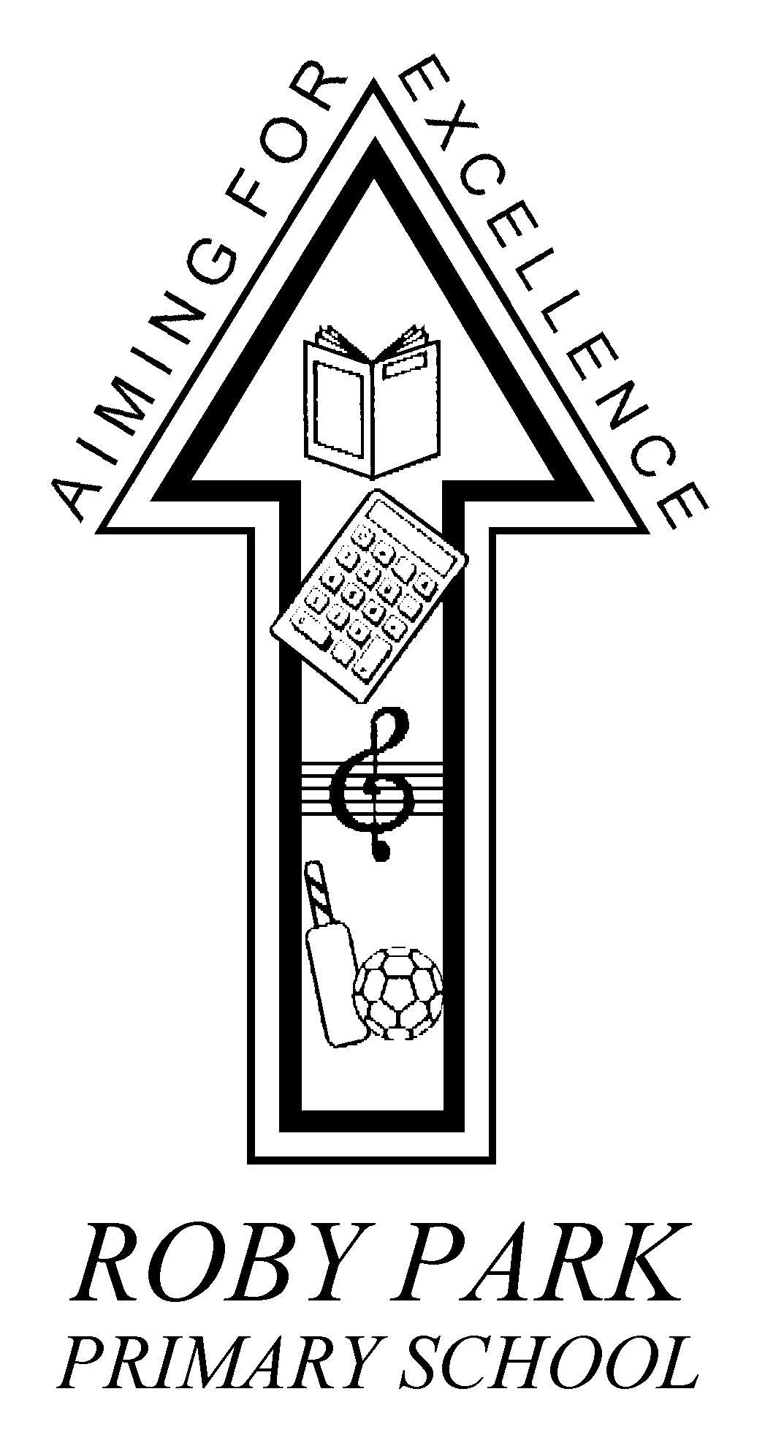

Roby Park Primary School

Easton Road

Huyton

Knowsley

L36 4NY

Tel: 0151 477 8340

Website: www.robyparkprimary.co.uk

E-mail: robypark@knowsley.gov.uk

Headteacher: Mrs K Allen
14th October 2019

Dear Parents/ Carers

Children’s Coats

As we are approaching the winter months, we are pleased to advise you that we have introduced a warm, waterproof winter coat for the children from our supplier Kitted Out.

The cost of the coat is £22.00 (for all sizes) It is available in sizes, 3-4yrs, 5-6yrs,
7-8yrs, 9-10yrs, and 11-12yrs. It is fleece lined and has a hood zipped into the collar, our school badge will also be included.

We have sample sizes that can be tried on after school between 8am- 8.45am and 3pm- 3.30pm, so please come and try before you buy. Order forms are also available in the office. We will need full payment at the time of ordering.

If you are interested in ordering a school coat that we have orders by Thursday 24th October at the latest.

Yours faithfully

Mrs Allen
Headteacher

