

Roby Park Primary School

Easton Road

Huyton

Knowsley

L36 4NY

Tel: 0151 477 8340

Website: www.robyparkprimary.co.uk

E-mail: robypark@knowsley.gov.uk

Headteacher: Mrs K Allen

5th September 2019

Dear Parents/Carers,

Speed Stacking Club: Year 1 and 2

We are writing to inform you that Mrs Tabener and Mrs Marnell will be running a Year 1 and 2 speed stacking club after school from 3pm-4pm, commencing Thursday 12th September, up to and including Thursday 24th October.
There are a maximum of 20 places available for this club which will be allocated on a first come, first served basis.

To make the allocation of places a fairer system, permission slips will no longer be accepted the same day that a club letter is sent home. Slips should be returned to your child’s class teacher the following morning.

Yours faithfully,
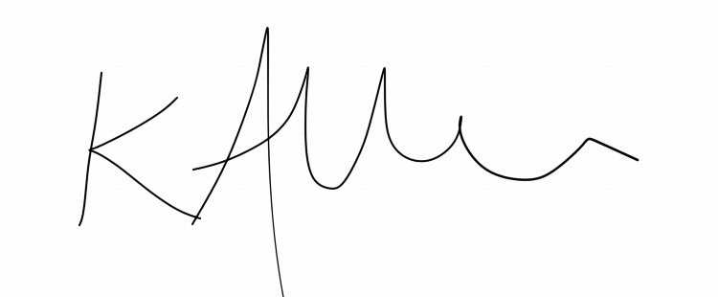

Mrs Allen
Headteacher
…………………………………………………………………………………………………………………………………………………
Speed Stacking Club: Year 1 and 2
Commencing:12.9.19

I give permission for my child:………………………………………………………………………to attend this club. If this club is cancelled I can be contacted on: ………………………………………………………………………………………………….
We cannot accept this slip without an up to date phone number.

I will collect my child at 4p.m.

Signed:…………………………………………………………………………………Parent/Carer

