Welcome to Reception

Meet the team
 |  | 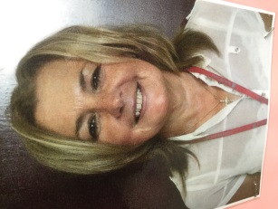
Mrs Doyle  YR Teacher  EYFS Phase Leader | Mrs Taberner  Nursery Nurse | Mrs Garcia  Nursery Nurse
If you have any queries or questions, please call the office to arrange an appointment to meet with your child’s class teacher.

Getting organised
Home Learning | Reading Books | PE Day
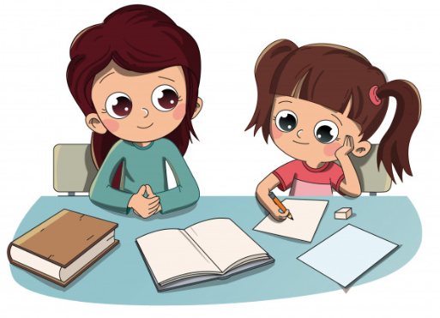
Talking home learning is set every Friday. | YR will have their reading books changed every Tuesday and Friday.  Children should read for 10 minutes every night and bring their reading record in signed, every day. | YR have PE every Thursday.  Children should wear their PE kit to school:  - Grey joggers  - black shorts  - White t-shirt  - School jumper  - Velcro pumps

Class assemblies and performances
- YR class assembly 9.00am 15th November.
- YR will be performing in their Nativity at 2pm on 17th December.

Social media
Website | Twitter | Facebook
Find out what we are learning about in YR at  http://robyparkprimary.co.uk/curriculum-2/year-YR/ | Follow all of our exciting news on our YR class Twitter page  @YearRecRobyPark | Check our Facebook page for regular updates  @Roby Park Primary School

